Guidelines

Space Requirements: Anywhere

Equipment Requirements: Easel paper or poster board and markers

Group Size: Any size

Alternative: You can start any group or gathering with this to let participants establish ownership of the space immediately.

Accessibility: Ensure the guidelines are somewhere everyone can physically reach to sign (ie: clear path of travel) (if they need assistance encourage them to ask for it-self-advocacy!). Ensure that the rules are read out loud prior to voting so everyone can have equal access to them. Post this on Facebook or your website for people that need to use augmentative communication devices will have time to type up suggestions.
Program Goals
  - Empower youth to take control of the class
  - Encourage participation
  - Introduce the idea of making decisions and choices for themselves
Instructions:
Have students come up with their own guidelines. They do great, and they will come up with almost all of these down below: if they don’t get to one of the guidelines by the end, maybe suggest it, but still let the class vote upon whether or not it enters their Preamble which starts, “We, the class/group of _________, agree to, and promise to obey, the following guidelines we have put forth: (Every guideline on the guidelines must be voted upon by the students so that they “buy” into it). At the end, everyone, teachers and facilitators included, sign the new preamble/constitution to be hung in the room during group/class.
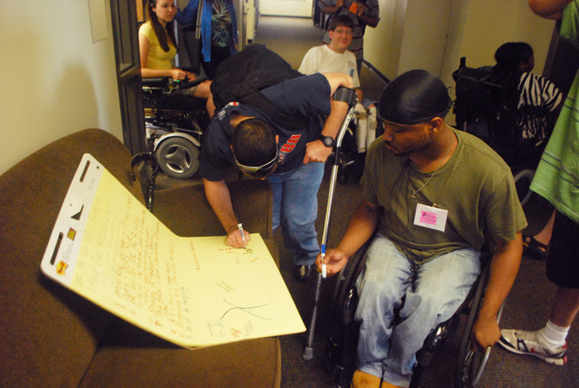
  - Vegas Rule: Confidentiality: What is said in here stays in here!
  - Be respectful of others!
  - Everyone is an expert and has something to say -- Be Honest!
  - Let others speak for themselves!
  - “I” Rule-only speak from personal experience, not for someone else.
  - Come to class!
  - Have Fun!

This can also be used when coming up with the parameters of the group (e.g. Should we have the meeting once a week, where should we have it, what time of day or day of the week works best? Do you need respectful language to be successful? etc.) We understand that sometimes we may not have a choice, due to funding or other reasons, but as much as possible, the young people with disabilities should be making these group decisions.

