**Recruitment & Retention**

The goal of this chapter is to give some examples of ways to get young people with disabilities involved with your Center.

**TIPS Before you begin!**

* Get a business card or put together fliers about you and your programs.
* Dress for your audience (students, parents, school teachers).
* Be respectful, friendly, and use words that are easy to understand.
* Don’t use Jargon or acronyms! (The alphabet soup of disability can be very intimidating and frustrating. Make sure to explain any that come up.)

**Things you should know when building a program/choosing a facilitator**

**Successful facilitators and programs may be able to:**

**TIPS:** Refer to students as students or by their name. Steer clear of using words like kiddo, kids, children, etc. Also Steer clear of making reference to “the real world.” Experience says nothing magic happens when we turn 18. The world is “real” to everyone.

1. Listen to what students are asking for and incorporate their suggestions. Have youth involved in the decision making process from beginning to end
2. Treat young people with disabilities with respect and as equals: Don’t talk down or at! Talk *with*.
3. Set guidelines or parameters as a group by voting and discussing. Have students decide what they will need to be successful! (See Appendix for classroom guidelines)
4. Use Know, Want to Learn Chart (KWL Chart) and use what you learn from it. Administer a survey to find out what they are interested in. (Best place to find out what the students want to do is from them! Give ideas or suggestions to get them talking, but let them make the final decisions on what the group will do.)
5. 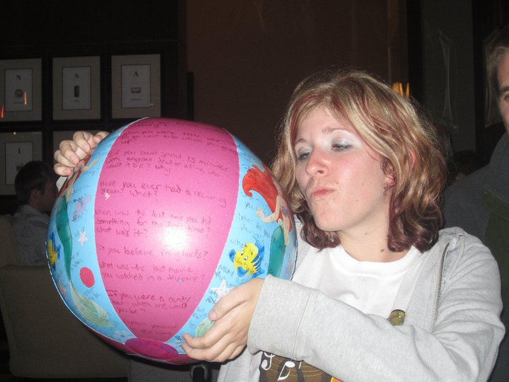Offer an information session before starting a program/training for youth. Students can then decide whether or not they want to join (if it is an optional program).
6. Make eye-catching information fliers! Or better yet, get a young person with a disability to make the flier!
7. **Be Passionate about the program! Speak with excitement, smile, and make it fun!**
8. Get to know the students with activities, icebreakers, and learn their names!

(See Appendix for possible icebreakers. This is a picture of the icebreaker ball with our own Eryn.)

**TIPS:**  Make sure accommodations are available for icebreakers. Examples: If it is a question, have the question available before hand on your website or Facebook so those using augmentative communication have time to type up an answer, or if it requires catching something, let students know they can designate a catcher if they need help, and think ahead on how to adjust questions to a yes or no answer for some disability groups.

1. 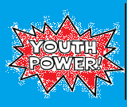Be honest and use respectful language. Facilitators must gain trust from others and the right language for the situation can go a long way toward winning that trust. But don’t try to use their jargon if you are not in with the generation! Youth can spot an imposter!
2. Be genuine. Don’t try too hard to dress young or act young, be yourself, THEY WILL KNOW!
3. Be flexible with your time. Youth generally aren’t available M-F, 9-5.
4. Provide food!

(Picture of Youth Power sign)

1. Have a fun celebration at the end of each gathering or youth meeting. (Give away gift certificates or other small item. These can be very small or inexpensive items that just add to the fun.)
2. Get familiar with the local Dollar Store for necessary supplies such as notebooks, papers for handout, or small gift giveaways.

**TIP:** Remember when you provide food that evening meetings may conflict with Personal Care Assistant/Meal time, and so provide food that is ‘meal worthy’ or remind people to pack their dinner. Also, remember to provide accommodating food to meet dietary needs. (ie: gluten free, sugar free food)

1. 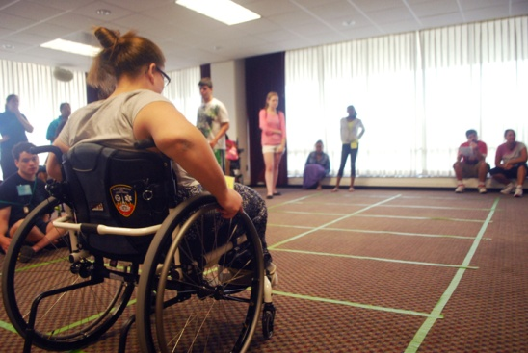Don’t be afraid of silence. If you ask a question, give enough time for students to process, and allow time for some disabilities that may need more time to process or more time to voice their answers.
2. Use games to get your points across whenever possible. (See Appendix for examples.)
3. Use props and audio or visual aids to help make points memorable. If you use media to emphasize points, make sure they are accessible.

(Girl in wheelchair going through squares on floor)

1. 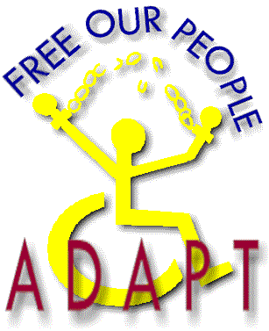Use topics chosen by youth to develop the curriculum or discuss during meeting. (See Appendix for examples of Ask Them/KWL Chart)
2. Bring speakers (like ADAPT, topic specific folks, etc.) Youth can’t be passionate about something they don’t know about!
3. Have a traditional meeting every other month that ends in a fun activity.

**Getting into the School**

* Contact employees from school. If you know a teacher or employee of the school, contact them first, if not, contact the next logical person (special education teacher, vocational prep teacher, principal, counselor, history teacher, etc.) Emphasize WHY they should talk to you!
* Check with adult consumers whose children are in school, or consumers who are in school themselves.
* Ask if you can make a presentation at school department meetings or teacher training days. (Sometimes referred to as early release and Teacher Workdays.)

**TIPS:** Bring fliers about your program or brochures from your Center to the meeting. Marketing is very important. **Also** – Make sure to dress appropriately for meetings!

* If a school invites you in for any other services from your Center, use that as a door to present youth programs.
* Emphasize why school staff should talk to you and listen to what they want. Communication is very important to build trust between you and the school.
* Ask the contact teacher to write an evaluation or blurb about your proposal and share with other teachers.
* Once you are in the school, ask if you can give additional presentations or provide other services to other teachers or classes. Some examples to offer them:
  + Disability Mentoring Day in October and that October is **National Disability Employment Awareness** month!
  + Disability History and Civil Rights in history classes during civil rights movement curriculum
  + Go into Individualized Education Plan (IEP) meetings with students as IL specialists. You can provide information on resources they can utilize.
  + Go into IEP meetings with students as advocates. Help students prepare before-hand so they are truly running the meeting and making their goals.
  + Disability Awareness panels for all school presentations.
  + Offer social groups for young people with disabilities
  + Youth Leadership Forums (See [www.aylf.net](http://www.aylf.net) and the YLF section of the APRIL Mentor/Mentee website)
  + Brainstorm the possibilities with some youth and other staff……or your Peer Mentors!

**TIPS:**  Give youth a reason to stay…use youth who are already involved in your Center to get your program up and going! You can also use Peer Mentor Programs or your Volunteer Programs and hire a peer mentor/volunteer to focus on youth if your other staff are too busy!! If you are training Peer Mentors, Vocational Rehabilitation may be able to help with a little funding for the job training!

Go to transition fairs to make connections.

* + Get a list of fair locations and dates from schools.
  + Check with main school district office or statewide office of public instruction. They also may have dates of fairs outside your area.
  + Be willing to pitch in or help set up transition fairs.
  + Contact the special education coordinator at school for additional resources.
  + Get familiar with school district websites and calendars so you know how

many schools are in your district, what kind of resources each school has, etc.

* Make sure to schedule meetings while the school is in session, not during the summer break or holidays.

**TIP:** Make sure to thank teachers and to follow up and follow through!

Be persistent! Be persistent! Be persistent!

**Advertise Effectively for Programs and Events**

1. Use social networking sites to advertise. (ie., Facebook, Instagram, Twitter, Youtube)
2. Be flexible with how you can contact the student. Not all students check their email as much as we as professionals do! Contact them through Facebook, call them, or text them.
3. Search for schools on Facebook for a group/fan page to get updates.
4. Create a brochure or website.
5. Develop a press packet for school teachers. It can include brochures, program overview, training contents, presenter contents, presenter information, etc (Include topical one-pagers that cover the amount of time, target audience, facilitators, AV needs, materials, resources, anticipated outcomes, lesson-plans, outlines, cross-disability offerings, and testimonials from teachers or students)

**Know Where To Go! Get creative when looking for youth!**

**-Adaptive Sports Programs**

**-After school programs**

**-Boys and Girls club**

**-Big Brothers Big Sisters**

**-Child Development Center (CDC)**

**-College disability advocacy groups**

**-Department of Public Instruction (DPI) websites**

**-Disability specific groups**

**-Faith Based Organizations**

**-Flagship**

**-Foster groups**

**-Girl/Boy Scouts**

**-High school clubs**

**-Home Community Based Services**

**-Libraries**

**-Local young person hang outs- bowling alley, parks**

**-Paratransit Buses**

**-Parent Groups**

**-Parent Teacher Association’s(PTA)**

**-Parks and Recreation**

**-School Hallways!**

**-Special Olympics**

**-Support groups**

**-Tutoring programs**

**-Vocational Rehabilitation (VR)**

**-VSA arts**

**-YMCA/YWCA**

**-Youth homes**

**-Youth Leadership Forum (YLF)**

**Follow-up Effectively**

* 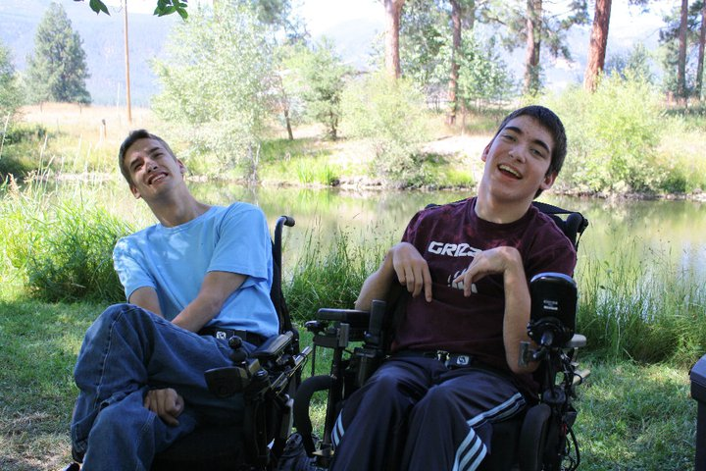With Teachers:

1. Write pre-post evaluations from students and teachers and send them results and ideas for improving the presentation in the future.
2. Write thank you notes to teachers within a week after the meeting or training is over.
3. Stay on teacher’s radar. (Make follow-up calls, send emails, ask for ideas about follow-up presentations and make sure they are still interested, add them to list serves.)

* With Students:

**FUN and LEARN!** Take youth group out doors and on activities as much as possible! Youth with disabilities tend to feel isolated. Teach them how they can recreate! Partner with other programs. Here is a picture of us at a local pond. We had the students learn about our statewide AT (Assistive Technology) program, and then they got to fish with the accessible fishing equipment!

1. Take surveys about what they are interested in to design curriculum. (Social, recreational, educational, etc.)
2. Get their contact information so you can contact them directly.
3. Do what you say you are going to do! Follow up from initial presentation to start a group and integrate youth into your Center
4. Let them know what other activities are happening in the community.
5. Remind students and teachers about getting in touch with you via email, face book, or by phone.
6. If students come back into the office, put them to work! Students will come back if they think they are making a difference!
   * Act as disability advisors for established groups like Girl Scouts
   * Run/create your Center Facebook page
   * 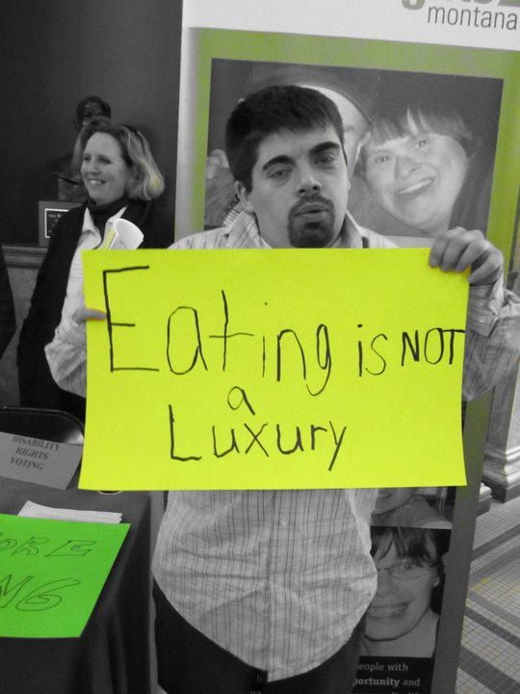Take leadership roles in your youth group
   * Help teach or give presentations
   * Mentor younger students
   * Participate in your Center rallies, call ins, letter writing, testifying
   * Be included in your social activities, open houses, etc.
   * Be on your Board of Directors
   * Hired as staff
   * Included in the Peer program
   * Invited to conferences where applicable and available
   * Included in your volunteer programs
   * Included on youth updates in staff updates so the whole IL staff knows what’s up.

**TIPS:** If you are worried about the issues surrounding guardianship for consumer paperwork and getting parent signatures, begin by documenting events as community events/outreach to underserved populations. You can also open the students up as quick I&Rs with basic information. Then if they come into your Center for more services or regularly attend youth activities, you can get the parent’s signature and open the youth as a consumer.

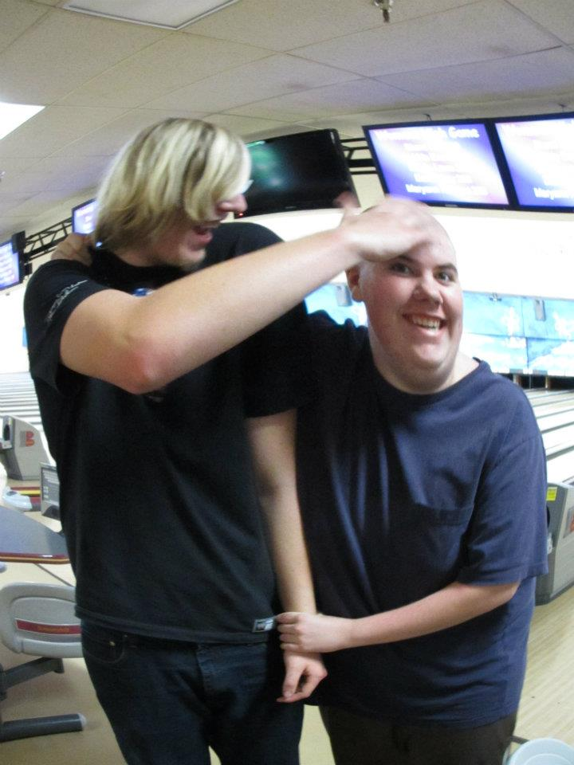

(Two people being silly at the bowling alley)

*Thoughts to Ponder:*

* *What are some new ways you can recruit?*
* *What have you done that has not worked for you?*
* *What have you done that HAS worked for you?*
* *What are feasible ideas for your staff time and Center?*
* *What services do you already offer as a CIL that appeal to youth and can be used to recruit? (cooking classes, computer labs, game nights, accessible gym, etc.)*
* *What free or low cost community activities are already happening in your area that appeal to youth? Can you recruit there? Can you make attending the event and teaching the youth how it can be accessible to them an activity for youth to be a part of and for you to advertise?*

**APPENDIX:**

A compilation of ice breakers carried out in youth programs run by the Peer-to-Peer Mentors. Feel free to tweak the activities and use them in ways that best fit your programs! Let us know if you want to add NEW activities to the manual.

Remember to try and make the activities accessible, and use them as a learning opportunity for youth to advocate for accommodations. Use your mentor to help brainstorm ways to make the ideas fit for your group and different abilities.

Note that each activity is in a format that allows for the facilitator to understand the points and areas of importance of the game. To facilitate each activity, it may take some run through and practice. Encourage staff to allow you to try it out and give feedback. This can be a great way to engage staff in what the youth program is doing and even be great way to learn more about staff!!

Last but not least, HAVE FUN.

Thank you!

*APRIL Youth Peer-to-Peer Mentors*

**Guidelines**

**Space Requirements:** Anywhere

**Equipment Requirements:**  Easel paper or poster board and markers

**Group Size:** Any size

**Alternative:** You can start any group or gathering with this to establish ownership of the space immediately.

**Accessibility:** Ensure the guidelines are somewhere everyone can physically reach to sign (ie: clear path of travel) (if they need assistance encourage them to ask for it-self-advocacy!). Ensure that the rules are read out loud prior to voting so everyone can have equal access to them. Post this on Facebook or your website for people that need to use augmentative communication devices will have time to type up suggestions.

**Program Goals**

* 1. Empower youth to take control of the class
  2. Encourage participation
  3. Introduce the idea of making decisions and choices for themselves

**Instructions:**

Have students come up with their own guidelines. They do great, and they will come up with almost all of these down below: if they don’t get to one of the guidelines by the end, maybe suggest it, but still let the class vote upon whether or not it enters their Preamble which starts, **“We, the class of _________ High School, agree to, and promise to obey, the following guidelines we have put forth:** (Every guideline on the guidelines must be voted upon by the students so that they buy into it). At the end, everyone, teachers and facilitators included, sign the new preamble/constitution to be hung in the classroom during class.

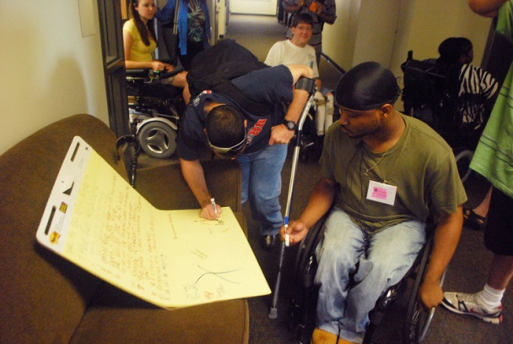

* 1. **Vegas Rule: Confidentiality: What is said in here stays in here!**
  2. **Be respectful of others!**
  3. **Everyone is an expert and has something to say -- Be Honest!**
  4. **Let others speak for themselves!**
  5. **“I” Rule-only speak from personal experience, not for someone else.**
  6. **Come to class!**
  7. **Have Fun!**

This can also be used when coming up with the parameters of the group (e.g. Should we have the meeting once a week, where should we have it, what time of day or day of the week works best? Do you need respectful language to be successful? etc.) We understand that sometimes we may not have a choice, due to funding or other reasons, but as much as possible, the young people with disabilities should be making these group decisions.

**Beach Ball**

**Space Requirements:** Anywhere

**Equipment Requirements**: Beach Ball, labels or marker to set it up

**Group Size**: Any size

**Alternative:** This can be used in any dead space of class, a “pick me up” from a lull in the group, ice breaker, and a way to bring in a new person joining the group.

**Accessibility:** Accommodations for catching the ball is ok - have the student the ball is meant to go to pick the finger, and then have a helper catch the ball and ask the person the question that is closest to the helper’s finger they chose. Or have the student ask for an accommodation reading their question it helps them practice asking for accommodations as well. Remember you might have to assist them in reading what is written on the ball. You can even have them say who they are going to pass the ball to next so it does not startle anyone expectantly.

**Program Goals**:

1. Increase awareness of each other
2. To increase participant comfort in asking for an accommodation

**Program Description**:

**Preparation:** Blow up beach ball and add any number of ice breaker questions using labels or a marker to write it on. You may use the example questions below, or add your own.

**Instructions**:

Have the students pick a finger that they are going to pick the question with. (don’t let them pick anything else with it ☺) Then throw the ball to them. Whichever question the finger that they picked is closest to is the question they have to answer.

|  |  |  |  |  |
| --- | --- | --- | --- | --- |
| If you were stranded on a deserted island, what are 3 things you would bring with you? |  | What was your dream growing up?  What was the last book you read? |  | What Talent do you wish you had?  What is one weird fact about you? |
| Are Clowns Cute or Creepy?  Do You Have/Want to have kids? How Many? |  | Do you play an instrument? What? Or What would you like to play?  How old are you? |  | Do you have Siblings? How Many?  If you could travel anywhere in the world, where would it be? |
| What is your favorite ice cream?  What is the worst movie ever? |  | Can you speak another language?  How do you vent your anger? |  | What is your biggest fear?  If you had one super power, what would it be? |
| What is your favorite drink?  What is your favorite Number? Why  If you moved to Sesame Street, who would you want as your neighbor? |  | What is your favorite Holiday? Why  What month were you born? |  | Do you have any tattoos piercings? Where? (Or where do you want one)  If you were a crayon, what color would you be, Why? |
| What is your favorite movie?  What cartoon character or cereal box character would you be? |  | What is the kindest act you have ever done?  Team Jacob or Team Edward? |  | If you could have any job in the world, what would it be?  What did you consider the most valuable thing you owned as a kid? |
| What is your favorite way to waste time without getting caught?  If there was a movie about your life, who would play you? |  | What was your least favorite subject in school?  What is the weirdest food you have ever eaten? |  | What is your favorite childhood memory?  When you were little, what did you want to be when you grew up? |
| Which of the seven dwarfs best describes you?  Have you ever dyed your hair? What color?  What book/tv character are you most like, why?  What is your middle name? |  | What do you think the most ultimate gift of the world is?  What CD/Song is in your stereo/ ipod right now?  What would the title of your Autobiography be? |  | If you could spend 15 minutes with anyone dead or alive, who? Why?  Have you ever had a recurring dream? What is it?  Name a song you know all the words to.  Night person or day person? |
| Based on something you have really done, how would you get in the book of world records?  What Sci-fi character would you be? ( Lord of the Rings, Star wars, Star Trek, etc.) |  | What’s the first thing you think of when you wake up in the morning?  If you could rid the world of one thing, what would it be? |  | When was the last time you did something for the first time? What was it?  Do you believe in ghosts? |
| What is your favorite weird food combination?  What was your favorite thing to do as a kid? |  | If you were a smurf, what would your name be?  What was the first concert you attended? |  | What was the last movie you watched in the theatre?  If you were a candy bar, which one would you be, Why? |
| What is your favorite line from a movie?  What is your worst habit/vice? |  | If you won $500,000 today, what would you do with it?  What’s your favorite thing to do in your spare time? |  | How would you explain yourself in one word?  What is your favorite TV show? |
| If you could time travel, where would you go, and what would you do.  Where were you born?  What was one time that you advocated (stood up) for yourself or someone else? |  | What is your goal for this year?  What is your nickname?  Would you rather live in Twilight or Harry Potter world? |  | What is your biggest pet peeve?  What is your favorite movie?  What’s your favorite sport?  Who is your hero?  What is a talent that you have? |
| What is the most embarrassing thing that happened to you?  What is the best thing that happened to you this week?  What do you like most about yourself? |  | What is the worlds best invention?  On Saturdays I like too…………  What are you going to be for Halloween? |  | What is your Favorite Food?  Do you have any pets- what?  Whats the funniest thing to happen to you all week? |

**Bumper Stickers**

**Space Requirements:** Enough room for each student to work in their own area

**Equipment:** Construction paper folded hotdog style, stickers, glue sticks, markers, anything else that can be added as a crafty way to make their bumper sticker

**Group Size:** 30 people or less (also depends on supplies you have)

**Alternative:** This can be an activity you back to at the end of the classes to ask if they would like to add anything or change anything to their bumper sticker. (they might decide to disclose their disability as they have found more community or pride).

**Accommodations:** This is a great activity a group that has low reading level, or short attention spans (younger youth, intellectual disability groups, groups that are new to each other)

**Program Goals:**

1. To understand self-actualization and to increase confidence.

2. To decrease the use of society pressures added to us by ourselves and peers.

**Program Description:**

**Preparation**

Have all supplies with you and ready to disperse in an accessible manner.

**Instructions:**

Discuss with the group how the labels we just talked about really are something society puts on us. Now is a time we can make our own label. Bumper stickers are on the back of most cars and it is something they believe in or they are proud of. They want to “advertise” about themselves. If they could make their label of what they are proud of what would that look like to them?

Give them about 10-20 minutes to decorate and make this bumper sticker something they can share with the whole class. Have each person present on their bumper sticker.

Note: If you have them add their names this could also be used as name tags during the classes to assist facilitator with names

**Ouch/Oops**

**Space requirement:** Anywhere

**Equipment:** None

**Group size:** Any

**Alternative:** This can also be added to the guidelines.

**Accessibility:** You may have to practice this at the beginning to ensure everyone understands it.

**Program goals:**

1. Participants will become aware of how what they say can affect other people.
2. Participants will become more comfortable with speaking up when someone says something hurtful.
3. Participants will become aware of person first language.

**Program description:**

**Preparation:** None

**Instructions:**

Explain to the participants that this activity is an ongoing activity just like the guidelines. When someone says something hurtful the person who is hurt says “ouch.” Then the person who said the statement says “oops.” This makes the participants aware of what they say to other people. An example of this would be using the word retarded. If I heard someone say this word I would say “ouch” and they would say “oops” since that word is hurtful. This can also help to reinforce the idea of person first language. **Ask Them/Know, Want, Learn (KWL) Chart**

**Space requirement:** Anywhere

**Equipment:** None

**Group size:** Any

**Alternative:** If you end a class/group early you can spend some time asking them what else they want to learn that day or next time. You can add this onto the end of the lesson each day. You can also make these topics into IL Skill classes/workshops in or out of school to increase their involvement with your Center.

**Accessibility:** Remember anything you write down you read out loud so all have access to it. Post this on Facebook or your website for people that need to use augmentative communication devices will have time to type up suggestions.

**Program goals:**

1. Participants will realize that their opinions do matter.
2. Facilitators will learn what the group wants from the course.

**Program Description**

**Preparation:** None

**Instructions:**

Ask the participants what they want from this class? What are some things they want from us? How can we help them? Remember that teachers come in and just go through a curriculum in trying to just get to the end of the year. We are probably the first experience they have had with people with disabilities as facilitators being open about disabilities. It is important for them to have a say in the class, that way they will have vested interest. It allows them to gain more ownership of the space and group/class. Don’t forget to explain why you cover different subjects. This can help them identify topics that they may not even be aware of, but need to be. (ie: Transportation issues and how to know who ADAPT is and what they do)

**Pictionary**

**Space Requirement:** Classroom/activity room with enough space to hang a large sheet of paper or a white board.

**Equipment:** Whiteboard or large sheet of paper, pens, pencils, markers, etc.

**Group size:** Group of 25 or less participants.

**Alternative:** This can be done to talk about society views, it can be done to lead into a Normal Box (see Normal Box activity description) discussion. Can be done as an ice breaker.

**Accessibility:** Ensure there is audio description of what is being drawn so there can be equal access. Or someone that cannot access the picture being drawn they can be the one giving the word to the drawer. It might be good for those that have hearing loss to have the word and image on an index card to show the individual. Have the drawing area somewhere that everyone in the group can physically access.

**Program goal(s):**

1. Participants will be creative in coming up with pictures. It makes them aware of things that have been talked about in class.

**Program Description:**

**Preparation:** If you want to put the word and image on an index card prior to class.

**Instructions:**

Choose a volunteer from the class to come up and whisper a word such as sad, happy or mad/or show the index card. Then continue to increase the difficulty level of the words. Be sure to give them some disability related words as well. Tell the drawer not to tell the other participants the word. They must draw the word without using any actual words in the picture. The other participants should guess what the drawer is trying to draw. Play continues through a few rounds of drawing.

If you want to talk about society or lead to the another activity of Normal Box (see Normal Box activity description), the last word you should give the drawer is normal. They will probably struggle with this word. After they work on it for a few minutes ask them if they want to have a classmate come up and assist, they whisper/or show index card the word to them and try as a team. After they struggle for a while, thank them and begin discussion. Talk with the students about what is normal and what is not normal? Can you taste normal? Can you feel normal? Smell normal? What makes someone normal, and someone else not? Explain that people with disabilities can be just as normal as people who do not have disabilities. Let the students use this to talk about experiences they may have had as well.

Pictionary words (or use your own): Just make sure the first couple of pictures are simple enough that the students will get them.

1. Pizza
2. Bananas
3. Cake
4. Snake
5. Guitar
6. Mouse
7. Bus
8. Instagram Symbol
9. Phone
10. Wheelchair
11. Stanley (Accessible Symbol)
12. Tree
13. Unicorn
14. Statue of Liberty
15. Normal

**Telephone**

**Space requirements:** Classroom/activity room

**Equipment:** None

**Group size:** Group of 10 or less participants

**Alternative:** This can be done as to increase communication skills as well. Understanding how self-advocacy can be more powerful.

**Accessibility:** Some may not want to have someone whisper in their ear think outside of the box to have them included (draw the word on their back, write I on a piece of paper, sign it, act it out, etc.)

**Program goal(s):**

1. Participants will learn how listening and speaking are part of communication.
2. They will learn that sometimes people need accommodations in order to communicate effectively.
3. Also can illustrate how if you are not AT your IEP meeting directly saying what your goals are, it is possible that when your messenger starts describing your goals, they may have got the message wrong, like in telephone.

**Program description:**

**Preparation:** None

**Instructions:**

This activity is just like the one everyone played as a child. Have the participants sit in a circle or some shape and think of a message to tell the starting person. The messages either relate to the class or to disability history. Whisper the phrase in the person’s ear and then have them pass the message on to the next person. Once the message has made it around the whole group have the last person say the message out loud. The catch is that the message can only be said once by each person. There is no repeating of the message. After each round talk about why the message did or did not make it around in its original form. Then discuss how listening and speaking are important parts of communication. Also be sure to talk with participants about how some people may be speaking as clearly as they can but they are still difficult to understand. Talk about how sometimes people may need accommodations in order to communicate effectively. An example of this could be someone who is deaf or hard of hearing. They may not be able to hear the message being said so they may need an interpreter or some other way to communicate.

**Say What?**

**Space requirements:** Classroom/activity room

**Equipment:** None

**Group size:** Group of 4 to 10 participants

**Alternative:** This can be done as to increase communication skills as well. This is a great facilitator training activity for thinking on your feet. When you lack confidence in a group setting or at an IEP meeting this can prepare on how to handle those situations.

**Accessibility:** You may want to write the words on the board so everyone can access the word even if it might be hard to understand.

**Program goal(s):**

1. Participants will learn that listening is very important.
2. They will also learn that sometimes people may need accommodations in order to communicate effectively.

**Program description:**

**Preparation:** None

**Instructions:**

Break group up into partners. Have them select who is partner one and who is partner two. They will have to talk about a word for thirty seconds and the other partner has to listen for thirty seconds without talking. Give partner one a word they have heard before (i.e.: shoes), have partner one talk about this word for thirty seconds. Give partner two a word they have heard before (i.e.: socks), have partner two talk about this word for thirty seconds as well. Then have partner one talk about a made up word for thirty seconds. Give partner two a made up word to talk about for thirty seconds.

After exercise is complete go through and ask each partner what the other said about their word. Ask the partners if it was correct or if anything was left out or added.

This activity shows how we may not hear everything that is being said and that things can distract us in how we hear. How we may only catch a part of the conversation and not all. In order to communicate effectively we have to not only talk effectively we also have to listen intensely.

Have them discuss what they felt like with the different words, how their bodies reacted. What were their thoughts like? After they went were they still concerned with what they just said rather than listening to the partner?

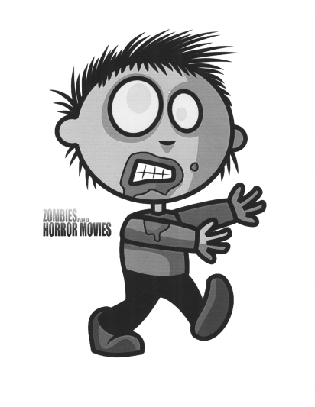**Zombies**

**Space Requirements:** Anywhere

**Equipment Requirements**: Zombie news article is optional; also optional zombie head Dollar Store squish ball

**Group Size**: Any size

**Alternative:** You could use this activity to also discuss bullying and how to not judge people based on appearance.

**Accessibility:** You may have to show a picture of a zombie, or bring a zombie figure for some groups to understand what zombies are.

**Program Goals**:

1. To increase participant’s awareness of teamwork and problem solving
2. To increase participant’s outlook on society

**Program Description**:

**Preparation:**

Hand out news article

**Instructions**:

Ask group this question, “***when the world is taken over by Zombies, what would your power or talent be to help save yourself or your family from the zombies brain sucking?”***

***This is meant to be a real life exercise, and not a matter of if, but when they take over.*** Let the group state their name, grade/position, and Zombie power. You may start by stating your name, your position, and your zombie power. (If working for an Independent Living Center now is also a great time for you to give a quick explanation of what an Independent Living Center is and is not.) After the last zombie power, you could point out that each power is unique and serves well to save that individual person and maybe a few friends, but in order to really overcome the zombies, we need to combine all of our powers together and work as a team, and that is a lot like the Independent Living Movement, and their first lesson in advocacy.

Depending on what group you are working with you can pass out the news article for proof (that they might ask for). Or if they might be unsure of what a zombie is you can show them the picture to give them clues.

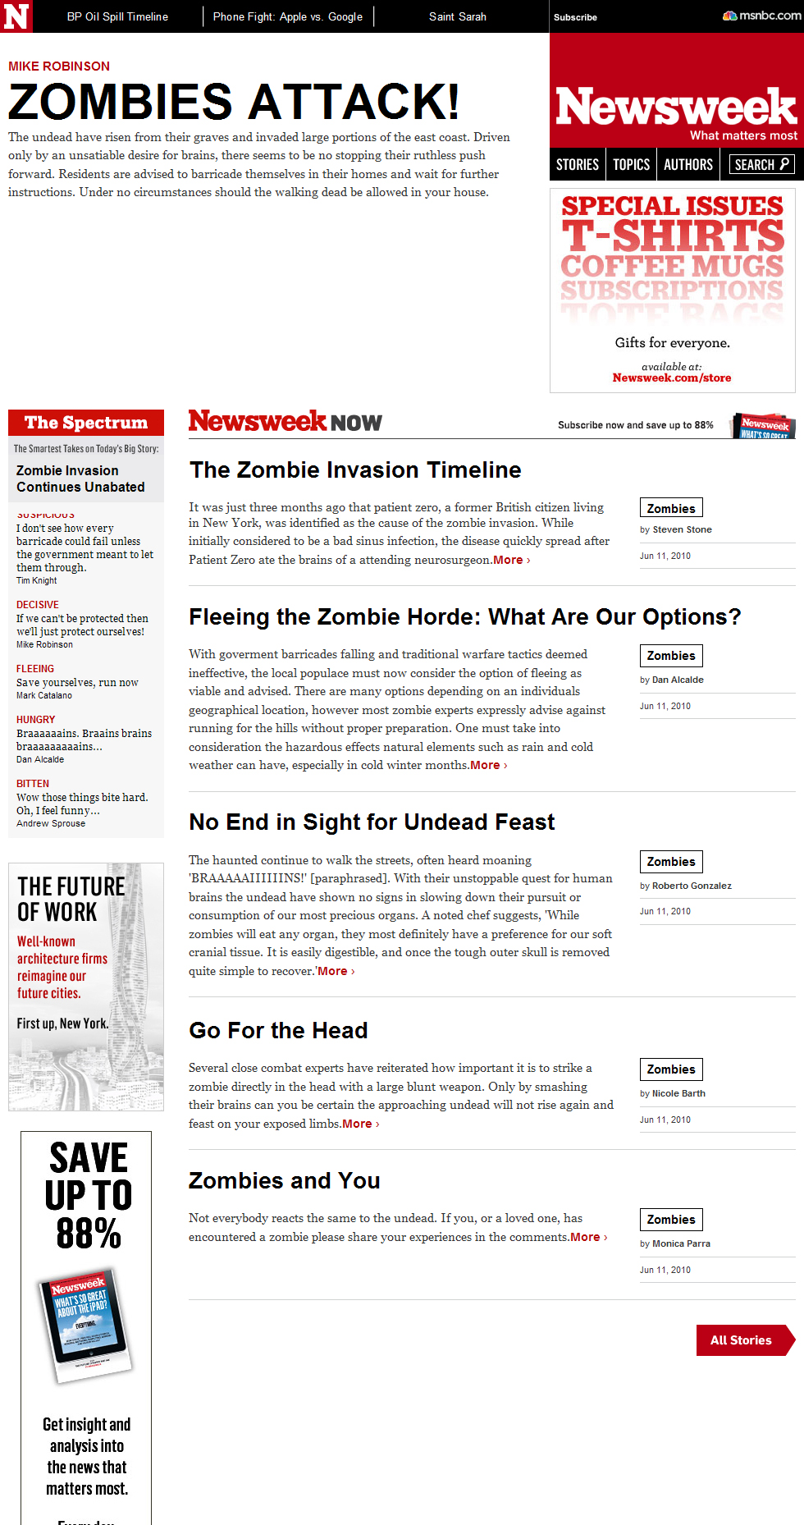

**Name Game**

**Space Requirements**: Anywhere

**Equipment**: Nothing

**Group Size**: Any size

**Program Goals**:

1. To increase social awareness of leaders of group
2. To increase social skills in group setting

**Program Description**:

**Preparation**:

None

**Instructions:**

Go through and ask each student their name. Have them match the first letter of their name with something that they like or something that describes them.

EX: Susie/shoes or sassy

This will help break ice with the group, and a great way for you to remember names

**Label Game**

**Space Requirements:** Room with tables to write on

**Equipment:** Sticky Label for each participant, paper, writing utensil

**Group Size**: Two or more

**Alternative:** This can be used to open a discussion on bullying.

**Accessibility:** This activity needs to be done with those that are able to understand that it is a game and will be able to separate the words from the lessons. A way to adapt it for a few in the group that can is tell them what the activity is before and explain the game, while letting them know this is a game not a way people are really feeling in the class. If they have experienced these labels let them know at the end will allow them to share their experience at the end. Also make sure the group knows what is on their groups labels. So, you might need to read the labels to different people in the group so they know what everyone else says-remember to not tell them their own! Make sure someone is audio describing what the drawing is in the group for individuals that cannot see the drawing. If someone has a latex allergy you can also stick the label to the front top collar of their shirt.

**Program Goals:**

1. To increase social skills in the community
2. To increase self-awareness of behavior
3. Introduce common thread throughout disability history and present of being labeled

**Program Description:**

**Instructions:**

Begin this exercise by first talking about invisible and visible disabilities. Invisible disabilities are sometimes a little harder to grasp, so brainstorm, have the group name some. Also have the group name some visible disabilities. Make sure to point out that there is not a hierarchy of disability and invisible disabilities are not more or less of a disability than visible ones.

Introduce ACCESS MAN (The universal symbol for accessibility, the man in a wheelchair), and point out that it does not represent all the different disabilities out there. The participants’ task is to break into smaller groups of three or more, depending on the group size, and come up with a sign for accessibility that represents the different types of disabilities better.

As the participants split into their groups, facilitators and a helper place labels on the foreheads of the participants. While the labels are being placed, explain that they may not look at their own labels or tell anybody else what their labels say, but they must treat each other according to what each person’s label is while brainstorming the new symbol. We are not responsible for the loss of any of their eyebrows, skin, or rashes that may develop from such labels on their heads. Students may be reluctant at first to treat each other by their labels, so facilitators must circulate through the groups, treating the students according to their corresponding label. Don’t be afraid!!! The students will understand after this activity that they are meant to feel awkward and singled out. This should continue on for 3-5 minutes. After this time, bring the students’ attention back to you, the facilitator, yet still having their labels in place on their forehead.

Have each group report back their ideas to replace access man. Note that the groups are not supposed to have a lot of ideas, and if this is so for your group of students, don’t be afraid to rush the group and point out to the larger group their lack of ideas. **“Seriously, you guys are bright, educated students, and this is all you could come up with?” WHY?**  Have participants come up with their own ideas of why they had such a hard time with this task. Note that some of their ideas should lead to the fact that they had labels on their heads and that was what they were focusing on.

**Getting Dr. Phil on the group:** How did this exercise make you Feel? After this discussion, students can remove their labels. You can ask the questions:

**“How many of you felt you knew what your label said?”**

Tying it all Together: The reason that we do this game is to point out that everyone in this room came to class today with your own labels. Labels that you have been carrying around with maybe your whole life. How much money you have, where you come from, what you look like, what sports you play, who your friends are, what music you listen too… We all know what it feels like to be frustrated, to wonder why something is easy for someone else or for everyone else but I struggle with it. Feeling isolated or alone isn’t just a disability experience, it is a human experience. There are two big reasons why people make us feel this way. The first is they do not know any better, or they are ignorant. They know nothing or very little about people with disabilities and do not accept anyone who is not just like them. The second is because we let them make us feel bad! Respect yourself and have pride in yourself, DISABILITY PRIDE!

**Label Game:**

|  |  |  |  |  |
| --- | --- | --- | --- | --- |
| **Ignore me completely** |  | **Do things for me without asking me** |  | **Laugh at all of my ideas** |
| **Help me out** |  | **You are afraid of me** |  | **Act like you can't hear me** |
| **Treat me like I'm dirt** |  | **Like all of my ideas** |  | **Follow my lead** |
| **Listened to every word I say** |  | **Stare at me** |  | **I have a mean temper** |
| **Hurt my feelings** |  | **Tell me how great I am** |  | **Ask me to repeat myself** |
| **I always get my way** |  | **Ask me what I think** |  | **Speak loud to me** |
| **Speak slowly to me** |  | **Treat me like I am sick** |  | **Ignore me completely** |
| **Hurt my feelings** |  | **Do things for me without asking me** |  | **Help me out** |
| **I always get my way** |  | **Treat me like I am stupid** |  | **Treat me like I'm dirt** |

**Why and Because**

**Space Requirements**: Anywhere

**Equipment**: Strips of paper and writing utensils

**Group Size**: Any size

**Alternative:**.

**Accessibility:**

**Program Goals**:

1. To facilitate getting to know each other
2. Make it fun
3. Practice communication skills
4. Foster creative thinking and thinking outside the box

**Program Description**:

**Preparation**:

Cut several strips of paper

**Instructions:**

Hand each student two strips of paper. On one strip of paper they can ask any question that starts with the word “why”. On the second strip of paper, they can write any statement or answer that starts with the word “because”. The answer does not have to relate to the real question they wrote. Then put all the questions in one pile, and all the answers in another, mixing each pile up. Have students take turns picking a sheet from each pile and getting up in front of the class and reading them. They are supposed to be silly, almost like a mad lib. This will break ice, and help students feel comfortable with speaking in front of the class.

**Two Truths and a Lie**

**Space Requirements**: Anywhere

**Equipment**: Nothing

**Group Size**: Any size

**Alternative:** Can use this to discuss safe and healthy relationships and boundaries.

**Program Goals**:

1. To increase social awareness of leaders of group
2. To increase social skills in group setting
3. To increase creative thinking
4. Promote comfort in sharing details about ourselves

**Program Description**:

**Preparation**:

None

**Instructions:**

Have each student take turns telling us two things that are true about themselves and one thing that is false. Make sure that they don’t tell us which is which! Then let other students raise their hand to see who can guess what is a lie. The student who guesses should then go next (unless they have already gone, then let them choose someone who has not gone yet).

**‘String Theory of Connectedness”**

**Space Requirements**: Anywhere

**Equipment**: Ball of String (make sure is not tangled)

**Group Size**: 2+

**Alternative:** This activity can be done for any subject or topic. You just change the question around to figure out who can all relate. Topics can include, self-advocacy, system change, teamwork, bullying, goal setting, problem solving, etc.

**Accessibility:** They may need assistance holding the string encourage them to ask for this.

**Program Goals**:

* + 1. Give students a chance to identify a strength or passion
    2. Focus on our similarities rather than differences
    3. Talk about community

**Preparation**:

Have group stand or sit in a circle

**Instructions:**

Facilitator identifies something that he/she is passionate about, and holds on to one end of the ball of yarn. She/he then asks “who else here is passionate about, cooking.” Ask participants who share this passion to hold up their hands if they share this passion. The facilitator then chooses on person to toss the ball of yarn to (make sure to let them know that it is encouraged to disclose an accommodation need if they have to). Then this person identifies his or her passion, holds on to a piece of the string then toss the ball on to someone else with their hand raised. Continue until all have participated.

**Discussion**

Have everyone hold up the hand they are holding their piece of string in. Note how we have created a web and that we are all connected together by the string.

Talk about that regardless of our disabilities, gender, age, race, or where we are from we are all connected, and that is why we make a strong community. Encourage participants to remember that in the future, that if one of us is fighting for a cause, then we are all fighting for a cause, because we are all connected together. Shake one of the strings and point out how the person across the web’s string shakes too. This illustrates how in a community, if one person is ‘shaken’ or discriminated against, then it affects all of us.

**Traffic Jam**

**Space requirement:** Classroom/activity room with free floor space

**Equipment:** Tape or paper

**Group size:** No more than 20 participants

**Alternative:** You can use this to talk about advocacy and how you have to jump through lines of people at times to really affect change with the right person. But, the impact along the path is huge. Goal setting process, and how it is not usually one step or one person involved.

**Accessibility:** You can put something down with texture that people can still roll across, but those that cannot see it will be able to feel it. Ensure the space for each person takes into account any mobility devices that someone may be using.

**Program goal(s):**

1. Participants will learn to work as a team.
2. Participants will become aware of the steps it takes to solve a problem.

**Program description:**

**Preparation:** Place tape or paper on the floor in a row of squares. Be sure to have one more square than you have people.

**Instructions:**

Divide the group evenly as possible depending on how many people are there.  To set up the game, place marked squares (one more than the number of people in the group) on the floor.  The boxes need to be placed in a straight line. Be sure to take into account all of the people in the group. There may be participants who have mobility devices. You can make the boxes bigger to accommodate them.  Have each person stand on a marked box, leaving the center open.  The challenge is for the groups on either side of the center unmarked box to completely change to the other side, by moving one at a time, like in a game of Checkers.  Players may move into the vacant spot next to them, or they may jump another player on the opposite side, but they can NOT jump a player from their own side.  Players may not move backwards, and two people cannot move at once.  At the end they should all have switched sides. Once the participants have finished talk about what the problem was and how they solved it. Be sure to emphasize that they worked together and not just one person did it all.

**Height Game**

**Space requirement:** Classroom/activity room with free floor space

**Equipment:** None

**Group size:** Group of 6-20 participants

**Alternative:** Understanding the group needs and how to communicate with others that have different accommodation needs.

**Accessibility:** You may want to have someone that can communicate with someone that is not able to see the different heights ask for other types of accommodations.

**Program goals:**

1. Participants will become aware of the value of team work.
2. Participants will become aware of the problem solving steps

**Program description:**

**Preparation:** None

**Instructions:**

Have the participant’s line up in a straight line facing the facilitator. Once they have all joined the line tell them that they have to get in order by height. The catch is that they cannot talk. They must figure out other ways to communicate to get the job done. Once they have completed the activity talk with them about what the problem was and how they solved it.