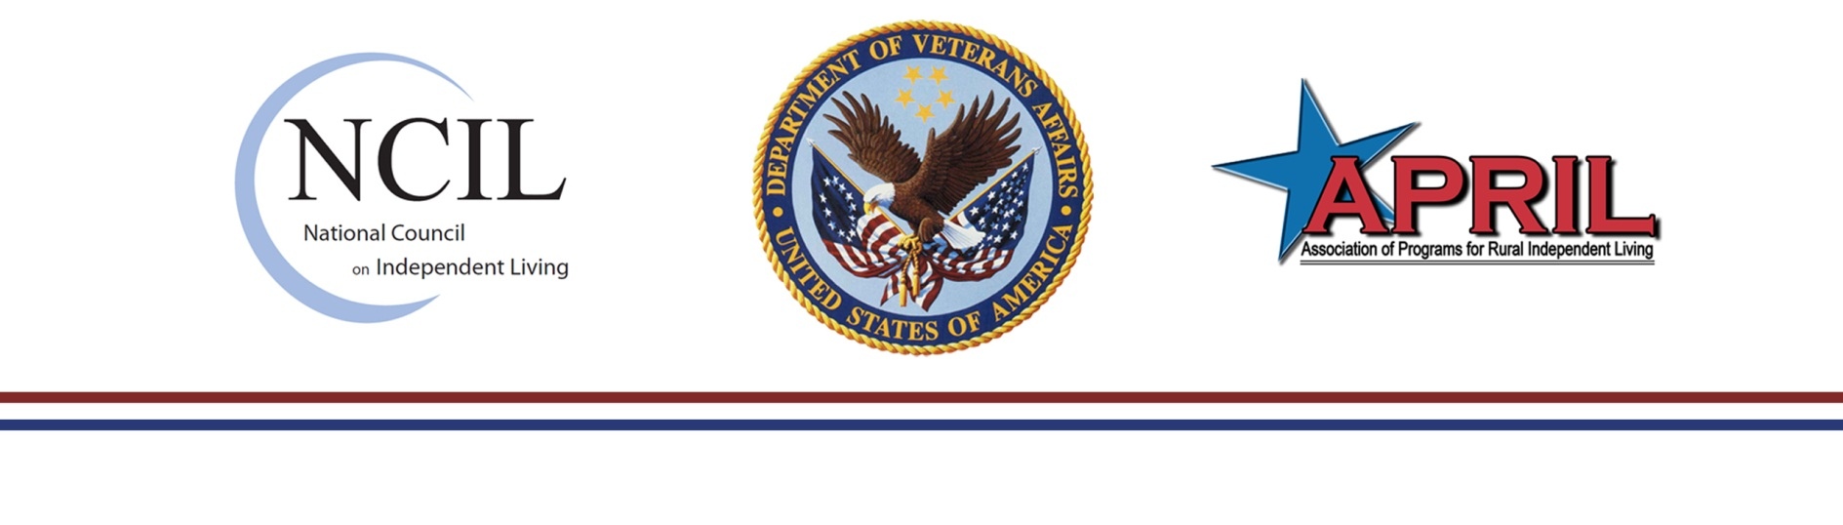



**How Centers for Independent Living (CILs) Can Assist**

**VR&E and Veterans**

**Background**

The National Council on Independent Living (NCIL) and The Association of Programs for Rural Independent Living (APRIL) have collaborated with the Department of Veteran Affairs Vocational Rehabilitation and Employment (VR&E) Service to develop a Memorandum of Understanding (MOU). This MOU will assist CILs and Vocational Rehabilitation Counselors (VRC) to collaboratively address Veteran needs. Information on NCIL and APRIL is on the back side of this information sheet.

**Services**

CILs provide services to the community as well as individuals. All CILs can provide:

* Information and Referral
* Peer Counseling
* Independent Living Skills Training
* Individual and Systems Change Advocacy

Staff at CILs can work with Vocational Rehabilitation Counselors (VRC) to collaboratively address Veteran needs. For Veterans receiving VR&E services under an independent living or vocationally-oriented rehabilitation plan, staff at a CIL may help by:

* problem solving and removing obstacles to completing the plan of services
* advocating for the Veteran
* teaching self-advocacy skills to increase Veteran empowerment
* finding a volunteer placement opportunity in the community
* informing the VRC about unmet needs that require further investigation
* coordinating activities not *specifically* in the Veteran’s rehabilitation plan that will help the Veteran achieve plan goals
* advocating on a Veteran’s behalf with a landlord for home modifications, especially if the housing is publicly subsidized (HUD, MSHDA, etc.)
* providing computer literacy training in the Veteran’s home, under some circumstances
* reporting concerns that need attention to the VRC as soon as possible (via email or telephone, depending on the VRC’s preference)
* maintaining contact with the Veteran to encourage participation in VR&E services
* helping coordinate other VA services through the VRC

Staff at the CIL will also help any consumer who is a Veteran contact the appropriate VA source for assistance.

**Contact Information**

Contact your local CIL to discuss other services that may be provided. To find a CIL near you, access:

<http://www.ncil.org/directory.html>

The National Council on Independent Living(NCIL), based in Washington, DC, is the longest-running national cross-disability, grassroots organization run by and for people with disabilities. Founded in 1982, NCIL represents thousands of organizations and individuals including: Centers for Independent Living (CILs), Statewide Independent Living Councils (SILCs), individuals with disabilities, and other organizations that advocate for the human and civil rights of people with disabilities throughout the United States. [www.ncil.org](http://www.ncil.org)

The Association of Programs for Rural Independent Living (APRIL) is also a national grassroots consumer controlled, nonprofit membership organization consisting of Centers for Independent Living, their satellites and branch offices, Statewide Independent Living Councils, other organizations and individuals concerned with the independent living issues of people with disabilities living in rural America. APRIL has membership in 42 states, the District of Columbia and Puerto Rico. [www.april-rural.org](http://www.april-rural.org)

January, 2012