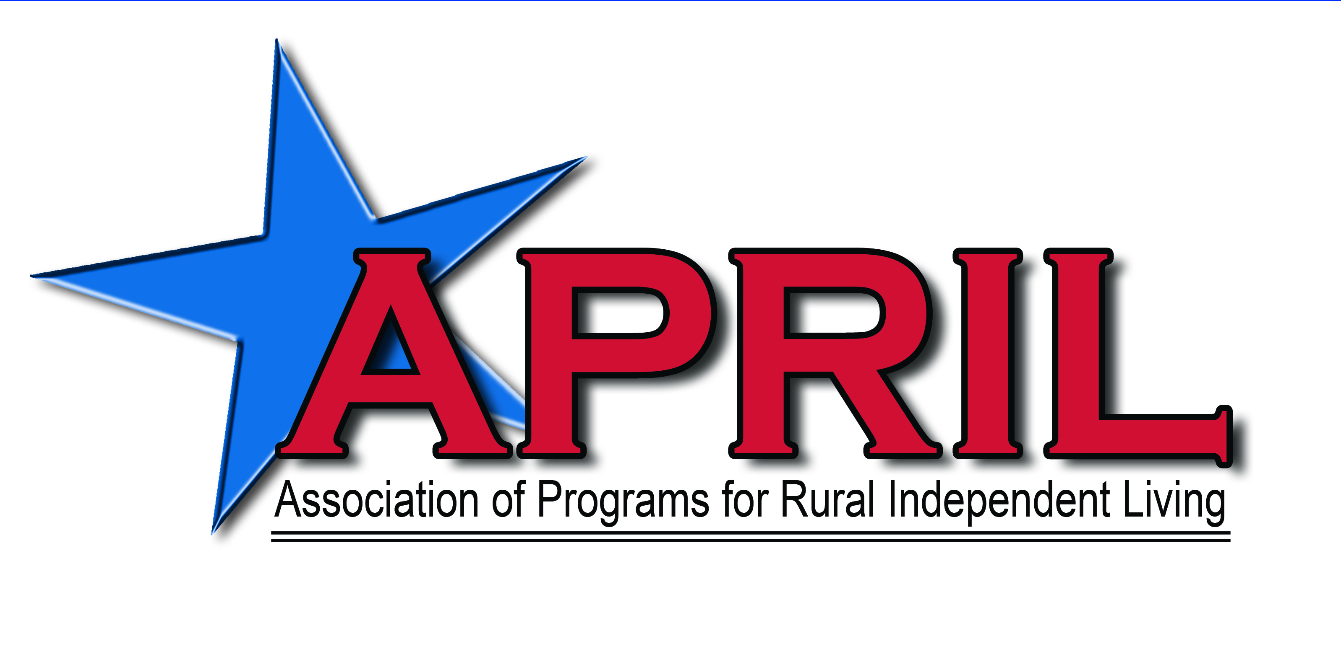

APRIL is a membership organization dedicated to advancing the rights of people with disabilities living in rural America. We strive to cultivate a culture of inclusivity throughout our organization which reflects that of our membership. We believe that diversity is an asset to be valued and respected. APRIL recognizes the uniqueness of each individual and uplifts the characteristics and intersectionality of characteristics within the human experience.

Position Title: Director of Training, Technical Assistance
Reports To: Executive Director
Pay: $68,000
Classification: Full Time (40 hours per week), Remote, Exempt, Benefits

Position Summary:
This position is responsible for the implementation of APRIL's Peer-to-Peer Mentoring Program and all training needs. Additionally, this position coordinates annual conference Audio-Visual, technical needs, distribution of, and summation of, evaluations. This position may be responsible for supervising, evaluating, and mentoring direct reports. The position also identifies emerging trends, gaps, and opportunities in the field of independent living. This position works with contracts with regards to specific training and technical assistance identified within a contract. The individual in this position will serve as a role model for people with disabilities as well as an advocate for disability rights and justice.
ESSENTIAL FUNCTIONS (with or without reasonable accommodations)
- In collaboration with the Director of Operations be a front-line resource person for CILs and SILCs by maintaining regular contact and updating contact information.
- In collaboration with APRIL’s membership DSEs, CILs and SILCs, develop and implement a plan to assist in their training and technical assistance needs.
- In collaboration with the Director of Operations, coordinate all AV and technical needs of the annual conference.
- Collect, analyze and report the annual conference session evaluations and ensure each presenter receives their evaluations in their entirety.
- Host and facilitate webinars, peer support calls, training, etc. with DSE, CIL and SILC boards and staff.
- Establish and maintain relationships with other agencies and organizations on a national level.
- Research and analyze consumer and community needs through forums, needs assessment, and satisfaction surveys and implement results.
- Collaborates with APRIL staff members to discuss issues, coordinate activities, and resolve problems.
- Represent APRIL and the disability community on various meetings, boards, committees, and councils.
- Carry out the Mission and Vision of APRIL.
- Participate in community events and public relations efforts, including public speaking to groups and disability awareness.
- Attend staff meetings and participate in development opportunities.
- Complete APRIL and grant reports in a timely and accurate manner
- Travel as needed.

QUALIFICATIONS
A relevant bachelor’s degree is required (or full-time relevant experience may be substituted on a year for year basis) and three years’ experience with program implementation and providing training to diverse populations. Specific qualifications include:

Specific qualifications include:
- Knowledge of disability rights and the Independent Living Philosophy.
- Ability to exercise initiative, ingenuity, and sound judgment.
- Strong organizational and customer service skills, attention to detail.
- Ability to network with individuals and groups of diverse populations.
- Experience in the delivery of presentations and leading groups.
- Leadership and interpersonal skills with diverse peers, consumer base, other staff members and management.
- Able to function independently and adapt readily to multiple assignments and deadlines.
- Knowledge and comprehension of standards of practice project compliance
- Computer proficiency.
- Effective written and oral communications skills.
- The ability to interact personally with people, businesses, and service organizations on all levels.
PREFERRED QUALIFICATIONS

- Multi-cultural
- Personal experience with a disability
- Background with CILs and SILCs
- Two years supervisory experience

APRIL is an Equal Opportunity Employer

TO APPLY: Please email your cover letter and resume to
Joan LaBelle, Executive Director at jlabelle@april-rural.org

