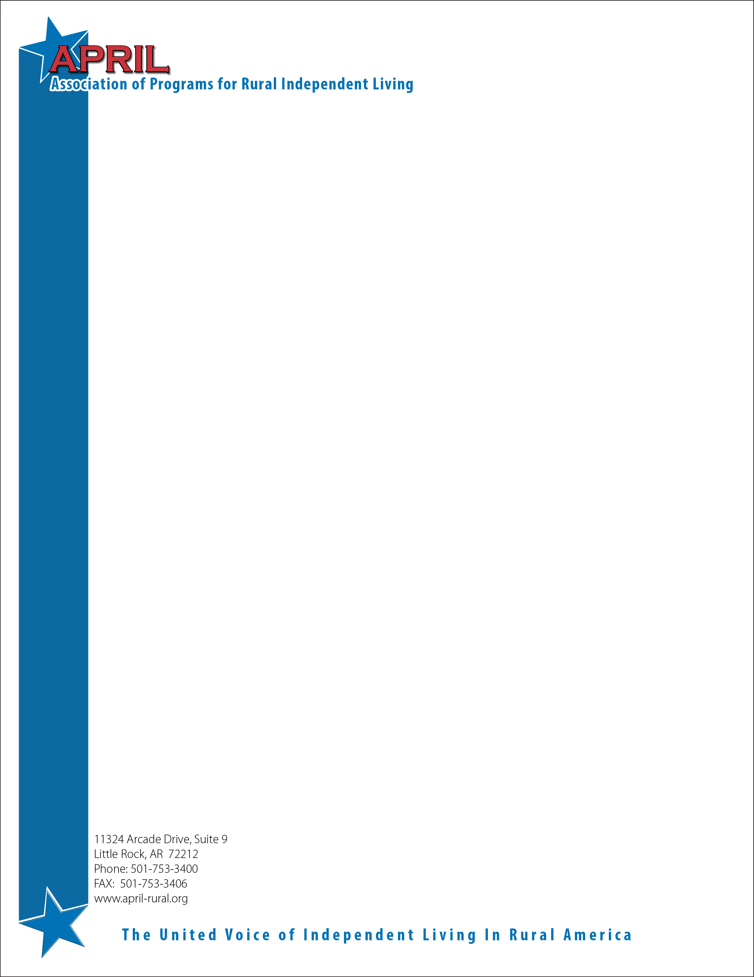

Dear APRIL Members/Community Partners/Supporters/Friends:

The Association of Programs for Rural Independent Living (APRIL) will be hosting the 23rd Annual National Conference on Rural Independent Living on **October 20-23, 2017** at the **Davenport Hotel, Spokane, WA** To precede its annual conference; APRIL is hosting an annual youth conference on October 20th. This year’s theme for the youth conference is “**Teamwork makes Dream Work**”. The youth conference will focus on how to make change step by step. Participants will learn and discuss the different populations that make up the disability community. They will discover how to be an ally for all people while becoming a strong self-advocate at the same time. They will also learn how to create change assertively for themselves and discover new supports to help them along their way. The conference will provide multiple opportunities to learn from seasoned advocates who have successfully made change for our nation.

We are asking for your help in sponsoring our youth conference. APRIL is one of the few national level organizations that promotes active involvement of youth with disabilities and dedicates an entire conference track to youth during their annual conference. Each year, we invite a diverse group of youth who are involved in the independent living movement, from across the nation, to gather and share knowledge and experiences. We are very proud that our youth conference is 100% youth-run. Our Youth Steering Committee decides everything from the conference agenda to the guest speakers, from the workshop topics to group activities to social events. We have found that much success can come from a group of dedicated youth working together to bring the next generation into the independent living movement.

Many interested youth conference attendees face a challenge when considering coming to the conference. We need your support to continue our efforts to reach out and get rural youth with disabilities involved. Your contribution will help many rural youth with disabilities attend this year’s youth conference, as well as the APRIL main conference. They will have the opportunity to become a part of a larger community, culture, and gain role models and support to help them open doors. Please consider sponsoring a youth to attend the conference, providing a general youth sponsorship, or making a financial contribution towards youth conference expenses, t-shirts, etc. Please know that any amount that you can donate is helpful to the success of our youth conference.

Your conference sponsorship would be greatly appreciated. We need your help to ensure that rural youth with disabilities are able to get more involved with the APRIL organization and lead the independent living movement on in the future. If you would like to support the youth conference this year, send your contribution by **September 15, 2017** to the APRIL office. Please feel free to contact us if you have any questions, and we look forward to your support.

Sincerely,

APRIL Youth Steering Committee