Click on the Share Icon:
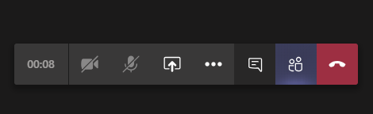
Make sure to check “Include System Audio”

Pick the window with the video you want to share:
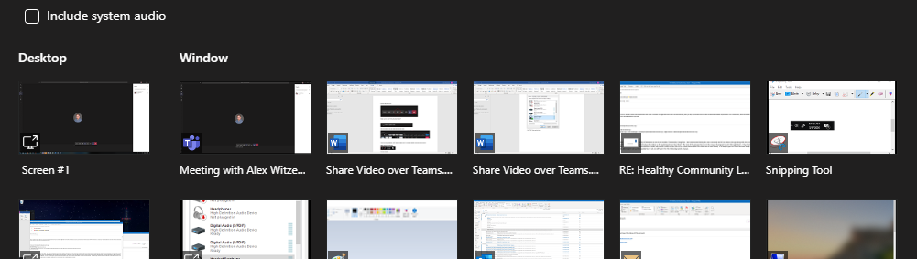
If you’re using a headset, you’ll need to make sure it’s set as the default communications device.
Right-Click the sound Icon
Click on Sounds
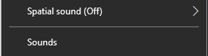
Go to the “Playback” Tab
Find your Headset in the list of devices
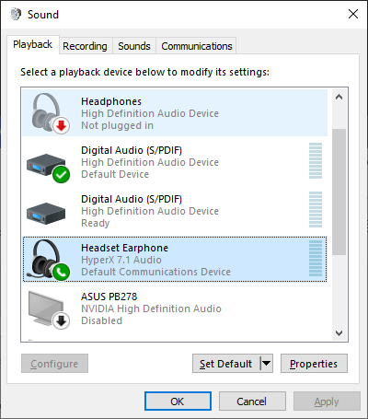
Right-click on the device and choose “Set as Default Device”

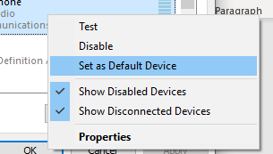
Should look like below:
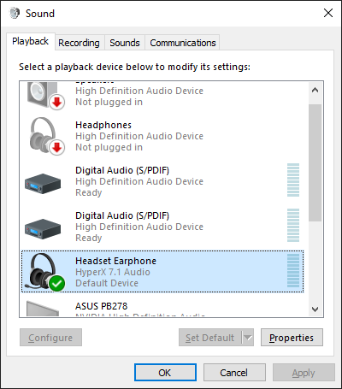
Click “OK”, then you’re done.

