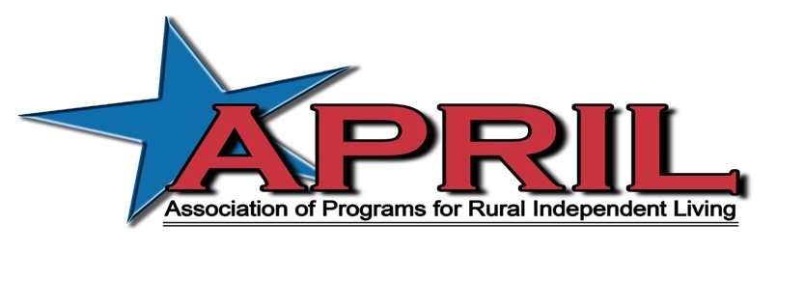

Letter from Billy Altom, Executive Director of APRIL

June 18, 2022

Dear APRIL Member/Community Partner,

The Association of Programs for Rural Independent Living (APRIL) will be hosting the 28th Annual National Conference on Rural Independent Living on October 12-14, 2022 at the Rosen Centre in Orlando, Florida. This year’s theme is “Reunited: The Power of Peer Support”.

The Annual Conference is APRIL’s culmination of the community support and activities provided by rural Centers for Independent Living (CILs) and the disability community. APRIL’s conference, with over 450 representatives from national CILs, and even international representation, is on the forefront of providing:
- Transportation Advocacy
- Peer to Peer Mentoring Opportunities
- Frontline Staff Training Opportunities
- Highlighting and Educating on Best Practices
- Youth Mentoring
- And much more

If you haven’t had the opportunity to attend an APRIL conference yet, we encourage you to join us in Orlando, Florida. Come see why we have gained a reputation of excellence when it comes to rural independent living.

A generous sponsorship gift would be greatly appreciated by both our APRIL membership and the communities in which we hold our conferences. Please feel free to contact me if you have any questions. I look forward to your support.

Sincerely,

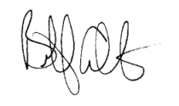
Billy Altom, Executive Director

The 28th Annual National Conference on Rural Independent Living
“Reunited: The Power of Peer Support”

October 12-14, 2022
Rosen Centre in Orlando, Florida

Conference Supporter Form

CONFERENCE SUPPORTER FORM

To fill out this form, click your mouse onto the gray shaded checkboxes or write-in fields. For write-in fields you will not see a cursor. However, when you begin typing words will appear. The shaded box will get bigger as the amount of text you write increases.

Option 1: Corporate Sponsorship

Yes, I want to be a corporate sponsor (choose one):

Gold ($50,000.00) Silver ($25,000.00) Bronze ($15,000.00)

Corporate sponsors receive waived conference fees, an exhibit booth (if requested), honorary one-year APRIL membership, and acknowledgement on our website, newsletter and Annual Report.

Option 2: Other Sponsorship Options

Yes, I want to be a Sponsor (choose multiple if applicable):

Break Sponsor $4,000
Breakfast Sponsor $7,000
Co-sponsor of Luncheon $2,000 - $3500
Luncheon Sponsor $11,000
Co-sponsor of Banquet $8,000 - $10,000
Sponsor of Banquet $17,000
Youth Dance $2,000
Youth Conference $8,000
CART Sponsor $4,000
ASL Sponsor $3,500
Keynote Live Stream Sponsor $500
Option 3: General Donation

I want to make a general donation to the conference in the amount of $

Name/Title

Organization

Address

City/State/Zip

Phone/FAX/ E-mail

You can also make a donation to APRIL on our website via PayPal by clicking this link.

Payment option 1: Pay by Check

Enclosed is a check for $ payable to APRIL.

If paying by check, return payments to:
APRIL
C/O Elissa Ellis
11324 Archade Drive, Suite 9
Little Rock, Arkansas 27712

Payment Option 2: Pay by Credit Card

You may pay by Credit Card by calling Elissa Ellis.

APRIL Office: 501-753-3400

Elissa’s Cell: 501-626-9539

