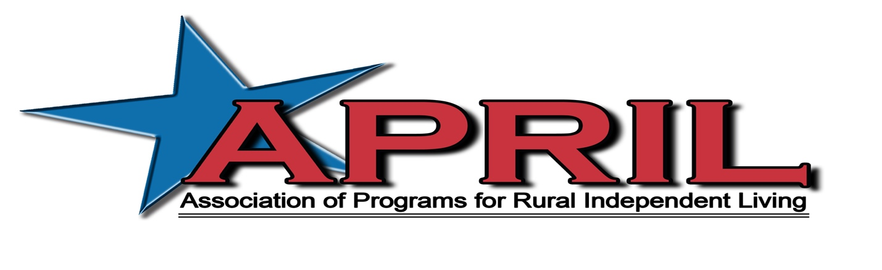

Letter from Billy Altom, Executive Director of APRIL

June 18, 2022

Dear APRIL Member / Community Partner,

The Association of Programs for Rural Independent Living (APRIL) will be hosting the 28th Annual National Conference on Rural Independent Living on October 12-14, 2022 at the Rosen Centre in Orlando, FL
This year’s theme is “Reunited: The Power of Peer Support”

APRIL’s annual conference is the highlight of our activities impacting rural centers for independent living and the disability community as a whole. APRIL’s conference, with over 450 representatives from centers located throughout the nation and internationally, is on the forefront of providing:
- Transportation Advocacy
- Peer to Peer Mentoring Opportunities
- Line staff training opportunities
- Highlighting best practices
- Youth mentoring
- And much more

If you haven’t had the opportunity to attend an APRIL conference yet, we encourage you to join us in Orlando, FL. Come see why we have gained the reputation of excellence in rural independent living.

Your conference sponsorship would be greatly appreciated by our membership and the communities in which we hold our conferences. Please feel free to contact me if you have any questions and I look forward to your support.

Sincerely,

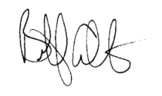
Billy Altom, Executive Director

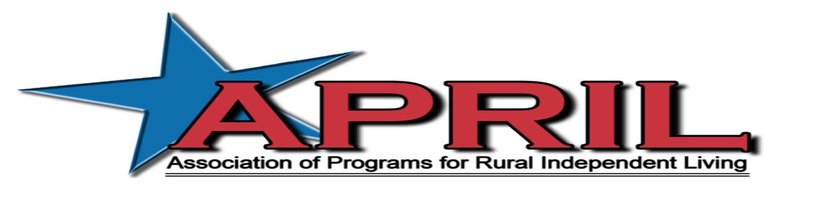
The 28th Annual National Conference on Rural Independent Living
“Reunited: The Power of Peer Support”

October 12-14, 2022
Rosen Centre
Orlando, Florida

Conference Supporter Form

CONFERENCE SUPPORTER FORM

Option 1:

Yes, I want to be a corporate sponsor (choose one):

Gold ($50,000.00) Silver ($25,000.00) Bronze ($15,000.00)

Corporate sponsors receive waived conference fees; Exhibit Booth if requested; Full Page color advertising space in the Conference Program; Newsletter and Annual Report Recognition as well as recognition on the APRIL Website. Corporate Sponsors will also receive honorary membership in APRIL.

Option 2:

Yes, I want to be a Food or Break Sponsor (can choose multiple)
:
Break Sponsor $4,000
Breakfast Sponsor $7,000
Co-sponsor of Luncheon $2,000 - $3500
Luncheon Sponsor $11,000
Co-sponsor of Banquet $8,000 - $10,000
Sponsor of Banquet $17,000
Youth Dance $2,000
Youth Conference $8,000
CART Sponsor $4,000
ASL Sponsor $3,500

Option 3:

Yes, I want to purchase Advertising space in the Conference Program. All ads are printed in Black and White. THE DEADLINE FOR CAMERA READY ADS IS August 19, 2022.

Back Cover 7 ½ x 10 $1000
Inside Front or Back Cover 7 ½ x 10 $800
Full Page 7 ½ x 10 $600
Half Page 7 ½ x 5 $400
Quarter Page Ad 3 ½ x 2 ½ $200
Business Card Ad Bus. Card $100

I want to make a general donation to the conference in the amount of $

Name/Title

Organization

Address

City/State/Zip
Phone/FAX/ E-mail

Payment option 1:

Enclosed is a check for $ payable to APRIL.

Payment Option 2:

You may pay by Credit Card by calling Elissa Ellis.

APRIL Office: 501-753-3400

Elissa’s Cell #: 501-626-9539

You may also use the “donate” button on the APRIL website via PayPal

RETURN PAYMENTS AND ADS TO: APRIL
11324 Arcade Dr., Suite 9
Little Rock, AR 72212
Elissa Ellis, Director of Operations

