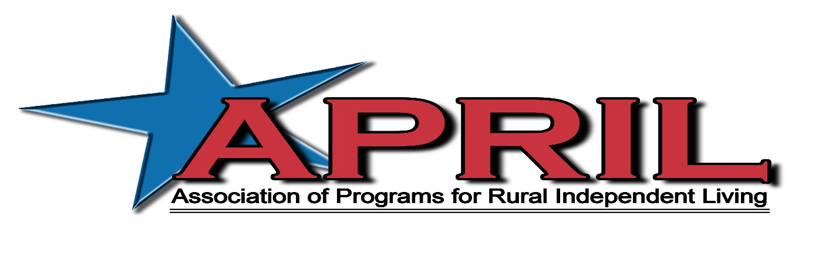

The Association of Programs for Rural Independent Living (APRIL) will be hosting our 26th Annual National Rural Conference on Independent Living, October 12-16, in your home or office!!! APRIL has gone virtual. The annual conference highlights our member’s activities impacting rural independent living and the disability community. APRIL’s conference, with over 450 participants from centers and SILC’s located throughout the nation, will join together in championing and sharing their knowledge in:

- Transportation Advocacy
- Peer to Peer Mentoring
- Line staff training
- Highlighting best practices
- Youth mentoring
- Online delivery and services
- Rural emerging practices
- And more!

If you haven’t had the opportunity to attend an APRIL conference yet, we encourage you to join us this year virtually. Although it isn’t quite the same as when we meet in person, we hope to bring our same APRIL feel.

Your conference sponsorship would be greatly appreciated by our membership and disability community. We have several support and payment options listed below for your convenience. Please feel free to contact me if you have any questions and I look forward to your support.

Sincerely,
Billy Altom

Billy Altom
Executive Director

CONFERENCE SUPPORTER FORM
Option 1: I want to be a corporate sponsor:

☐ Gold ($50,000.00) ☐ Silver ($25,000.00) ☐ Bronze ($15,000.00)

Corporate sponsors receive waived conference fees; a logo, link to your website, and link to your optional zoom room if you choose to have one on our Exhibit tab on the conference website if requested; Newsletter and Annual Report Recognition as well as recognition on the APRIL Website. Corporate Sponsors will also receive honorary membership in APRIL.

Option 2: I want to be a Food/Break Sponsor:
☐Zoom Sponsor $100-$5,000
☐ Tech support $50-$1,000

Option 3: I want to sponsor youth
☐ Youth Attendee Scholarship $50-$200

Option 4: I want to sponsor accommodations
☐ ASL Interpreters $100-$10,000
☐ CART (Real Time Captioning) $100-$10,000
☐ Other Accommodations_______________ $100-5,000

Option 5: I want to sponsor general conference needs
☐ Raffle items for end of conference raffle $50-$5,000

Option 6: I want to purchase Advertising space on the Conference Website. DEADLINE FOR Web READY ADS IS October 1, 2020

☐ Web ready Ad on the Advertising Sponsors Tab of the Conference Website $50
☐ Web ready Ad on the Advertising Sponsors Tab of the Conference Website and a mention in the opening remarks of your organizations name and brief description of who you are $200

Option 7: I want to make a general donation to the conference in the amount of $ _______

Name/Title _______________________________________________________

Organization ______________________________________________________

Address __________________________________________________________

City/State/Zip _____________________________________________________

Phone/FAX/ E-mail ________________________________________________

Payment option 1:

Enclosed is a check for $ ______________ payable to APRIL.

Payment Option 2:

You may pay by Credit Card by calling Elissa Ellis. APRIL Office: 501-753-3400

Elissa’s Cell #: 501-626-9539 OR You may use the PayPal “donate” button on the APRIL website

Thank you for your support. With community we are stronger, thank you for being a part of our community. RETURN PAYMENTS TO:
APRIL
11324 Arcade Dr., Suite 9
Little Rock, AR 72212
Elissa Ellis, Director of Operations

