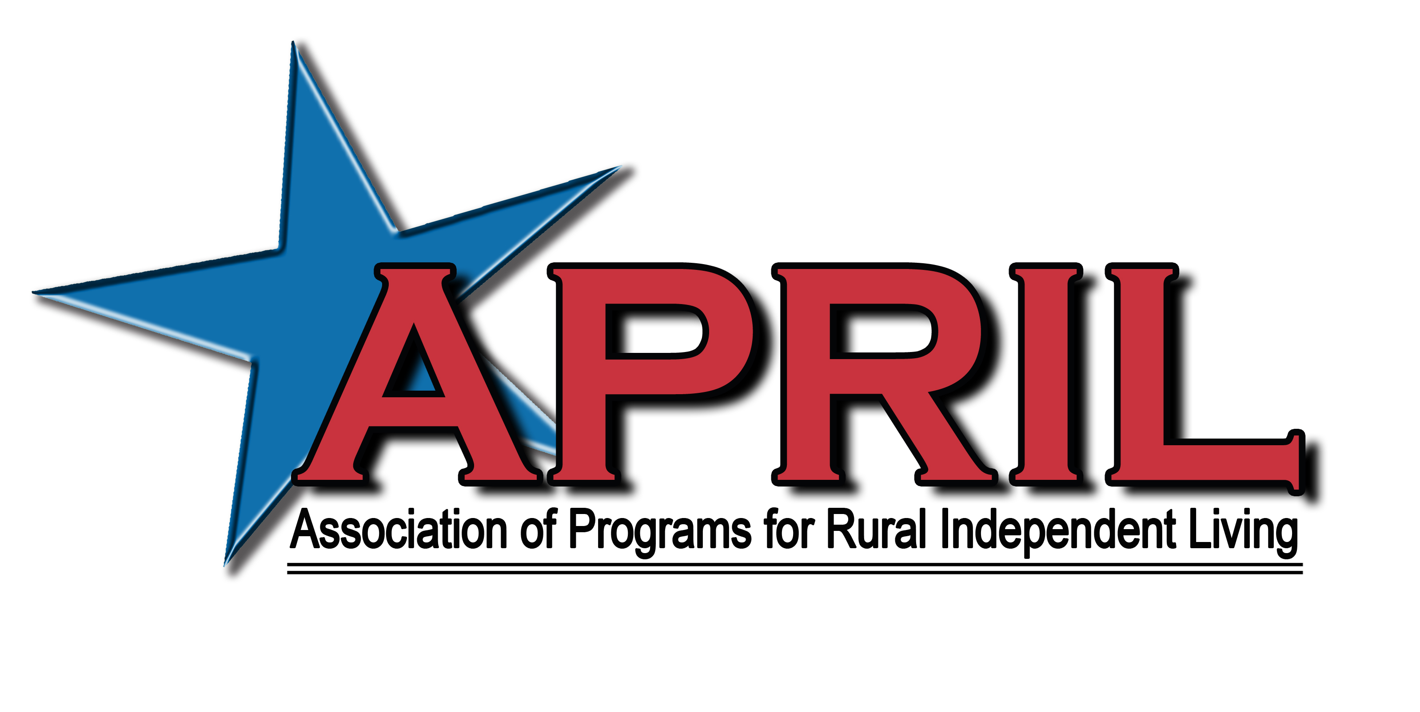

May 19, 2013

Dear APRIL Member / Community Partner,

The Association of Programs for Rural Independent Living (APRIL) will be hosting the 19th Annual National Conference on Rural Independent Living on October 25-28, 2013 at the Marriott Tulsa Southern Hills in Tulsa, Oklahoma! This year’s theme is “Independent Livin’ On Tulsa Time - Honoring the Past & Celebrating the Future”.

APRIL’s annual conference is the highlight of our activities impacting rural centers for independent living and the disability community as a whole. APRIL’s conference, with over 300 representatives from centers located throughout the nation and internationally, is on the forefront of providing:
- Transportation Advocacy
- Peer to Peer Mentoring Opportunities
- Line staff training opportunities
- Highlighting best practices
- Youth mentoring
- And much more

If you haven’t had the opportunity to attend an APRIL conference yet, we encourage you to join us in Tulsa. Come see why we have gained the reputation of excellence in rural independent living.

Your conference sponsorship would be greatly appreciated by our membership and the communities in which we hold our conferences. Please feel free to contact me if you have any questions and I look forward to your support.

Sincerely,

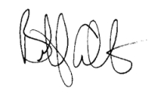
Billy Altom, Executive Director

The 19th Annual National Conference on Rural Independent Living

“Independent Livin’ On Tulsa Time – Honoring the Past & Celebrating the Future!”

October 25 – 28, 2013
Marriott Tulsa Southern Hills
Tulsa, Oklahoma

CONFERENCE SUPPORTER FORM

Option 1:

Yes, I want to be a corporate sponsor:

__ Gold ($50,000.00) __ Silver ($25,000.00) __ Bronze ($15,000.00)

Corporate sponsors receive waived conference fees; Exhibit Booth if requested; Full Page color advertising space in the Conference Program; Newsletter and Annual Report Recognition as well as recognition on the APRIL Website. Corporate Sponsors will also receive honorary membership in APRIL.

Option 2:

Yes, I want to be a Food/Break Sponsor:
__ Break Sponsor $1000
__ Breakfast Sponsor $2000
__ Co-sponsor of Luncheon $1000 - $1500
__ Luncheon Sponsor $4000
__ Co-sponsor of Banquet $4000 - $6000
__ Sponsor of Banquet $10,000

Option 3:

Yes, I want to purchase Advertising space in the Conference Program. All ads are printed in Black and White DEADLINE FOR CAMERA READY ADS IS August 23, 2013

__ Back Cover 7 ½ x 10 $1000
__ Inside Front or Back Cover 7 ½ x 10 $800
__ Full Page 7 ½ x 10 $600
__ Half Page 7 ½ x 5 $400
Yes, I want to make a general donation to the conference in the amount of $ _______

Name/Title _______________________________________________________

Organization ______________________________________________________

Address __________________________________________________________

City/State/Zip _____________________________________________________

Phone/FAX/ E-mail ________________________________________________

Payment option 1:

Enclosed is a check for $ ______________ payable to APRIL.

Payment Option 2:

You may pay by Credit Card by calling Elissa Ellis.

APRIL Office: 501-753-3400

Elissa’s Cell #: 501-626-9539

RETURN PAYMENTS AND ADS TO: APRIL
2001 Pershing Circle, Suite 200
North Little Rock, AR 72114
Elissa Ellis, Director of Operations

