Kahoot User Guide

From the home page, click on Kahoots:
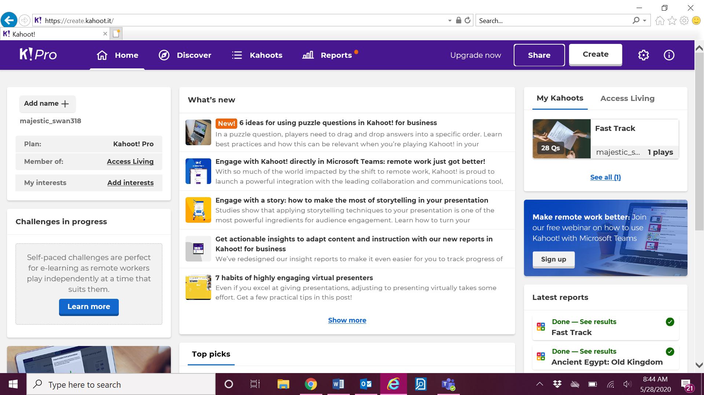

Click on Favorites:
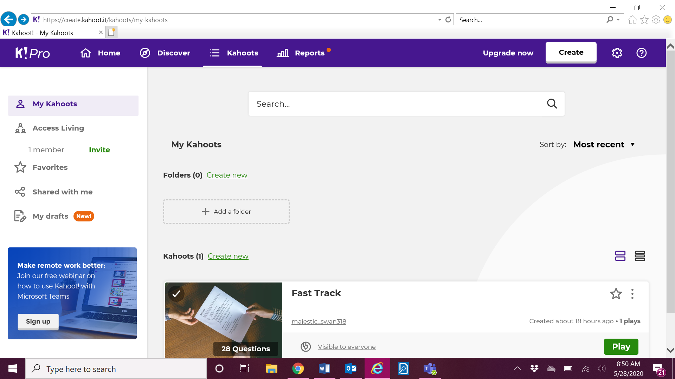
Click on My Kahoots for the Kahoots we have created:
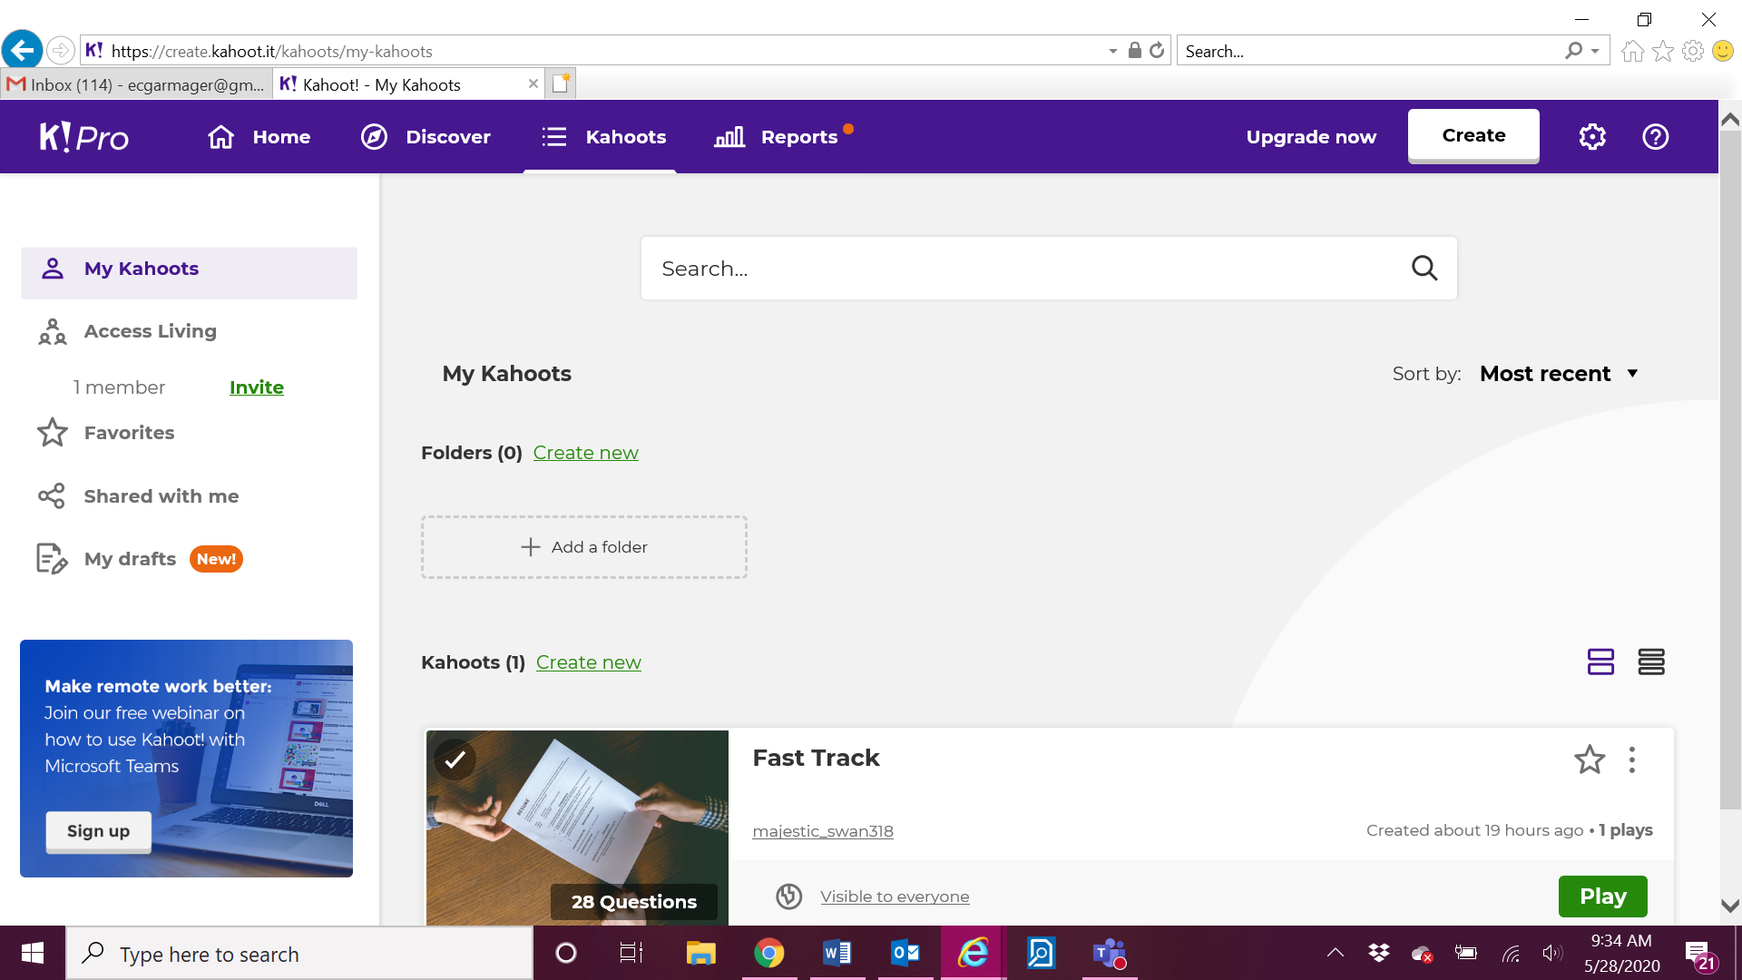
This is where you will find the Kahoots that you’ve favorited. Click on the Kahoot you want to present.
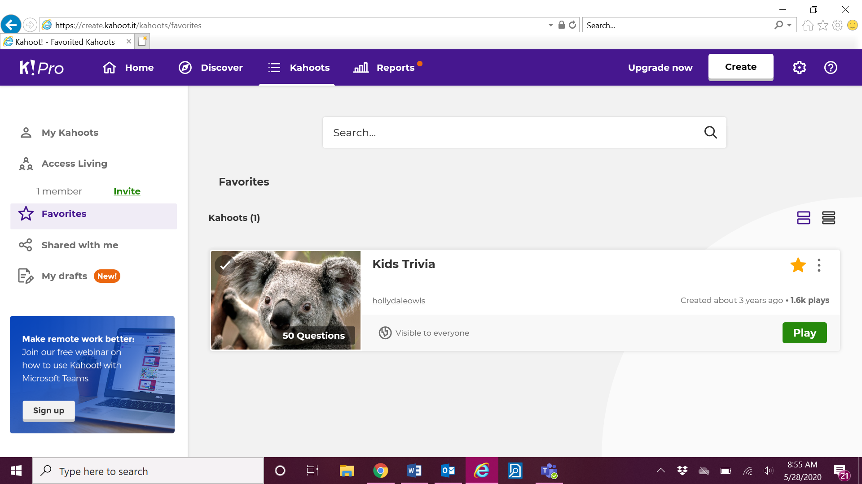

Click Play:
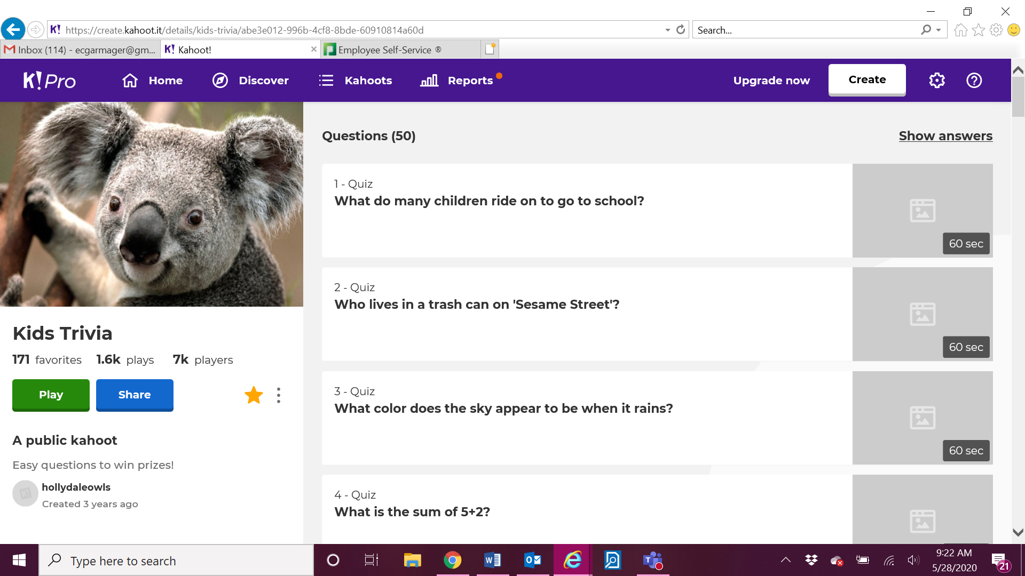

Click Present:
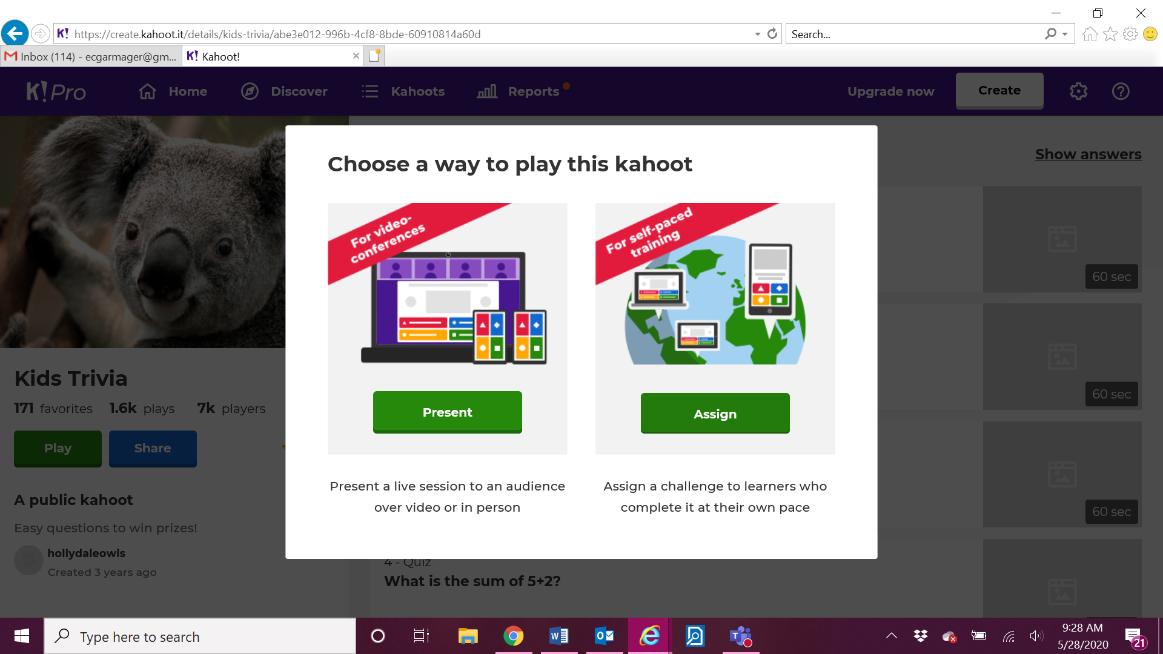

To find new Kahoots - rom the home screen, click on Discover:
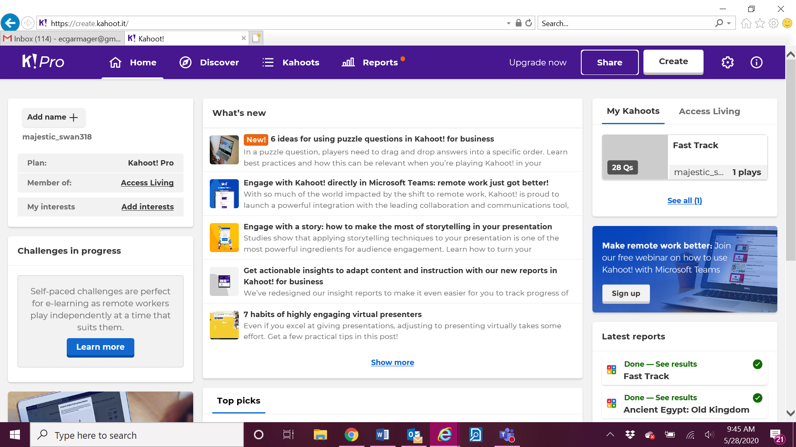

Type in any Kahoot you want to search for (any topic or subject):
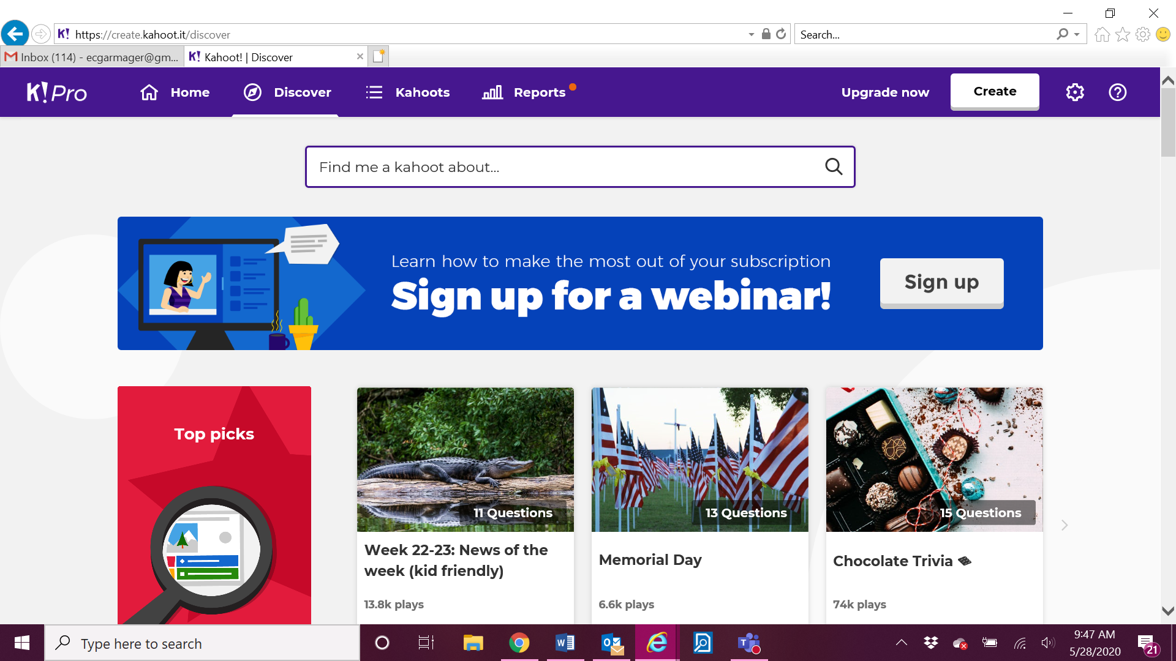

If you like the Kahoot, you can add it to your favorites:
