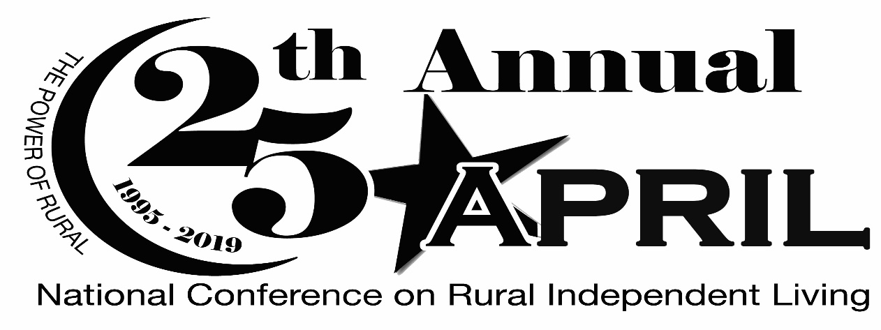

The Association of Programs for Rural Independent Living (APRIL) will be hosting our 25th Annual National Rural Conference on Independent Living, October 26 – 28, in Grand Rapids, Michigan. The conference theme this year is The Power of Rural. The annual conference highlights our member’s activities impacting rural independent living and the disability community. APRIL’s conference, with over 450 participants from centers and silc’s located throughout the nation, will join together in championing and sharing their knowledge in:

- Transportation Advocacy
- Peer to Peer Mentoring
- Line staff training
- Highlighting best practices
- Youth mentoring
- And much more

If you haven’t had the opportunity to attend an APRIL conference yet, we encourage you to join us in Grand Rapids. Come see why we have gained a reputation of excellence in rural independent living.

Your conference sponsorship would be greatly appreciated by our membership and the community in which we hold our conference. We have several support and payment options listed below for your convenience. Please feel free to contact me if you have any questions and I look forward to your support.

Sincerely,
Billy Altom

Billy Altom
Executive Director

CONFERENCE SUPPORTER FORM

Option 1:

I want to be a corporate sponsor:

__ Gold ($50,000.00) __ Silver ($25,000.00) __ Bronze ($15,000.00)

Corporate sponsors receive waived conference fees; Exhibit Booth if requested; Full Page color advertising space in the Conference Program; Newsletter and Annual Report Recognition as well as recognition on the APRIL Website. Corporate Sponsors will also receive honorary membership in APRIL.

Option 2:

I want to be a Food/Break Sponsor:
__ Break Sponsor $4,000
__ Breakfast Sponsor $7,000
__ Co-sponsor of Luncheon $2,000 - $3500
__ Luncheon Sponsor $11,000
__ Co-sponsor of Banquet $8,000 - $10,000
__ Sponsor of Banquet $17,000
__ Youth Dance $2,000
__ Youth Conference $8,000
__ CART Sponsor $4,000
__ ASL Sponsor $3,500
__ Youth Attendee Scholarship $100-$2,000

Option 3:

I want to purchase Advertising space in the Conference Program. DEADLINE FOR PRINT READY ADS IS August 10, 2019

__ Back Cover 7 ½ x 10 $1000
__ Inside Front or Back Cover 7 ½ x 10 $800
__ Full Page 7 ½ x 10 $600
__ Half Page 7 ½ x 5 $400
__ Quarter Page Ad 3 ½ x 2 ½ $200
__ Business Card Ad Bus. Card $100

I want to make a general donation to the conference in the amount of $ _______

Name/Title _______________________________________________________

Organization ______________________________________________________

Address __________________________________________________________

City/State/Zip _____________________________________________________

Phone/FAX/ E-mail ________________________________________________

Payment option 1:

Enclosed is a check for $ ______________ payable to APRIL.

Payment Option 2:

You may pay by Credit Card by calling Elissa Ellis.

APRIL Office: 501-753-3400

Elissa’s Cell #: 501-626-9539

You may also use the “donate” button on the APRIL website via PayPal

RETURN PAYMENTS AND ADS TO: APRIL
11324 Arcade Dr., Suite 9
Little Rock, AR 72212
Elissa Ellis, Director of Operations

